Course Project - Final Analysis
Shaun Pritchard
Rasmussen College
QMB4900
James Grooms
February 7, 2021

Course Project - Final Analysis
This is the Super Shoppers capstone project final analysis. This paper is combined of the three categorical departments based as independent variables. Such as the warehouse case study, point-of-sale case, the accounting department case study. This is a collaboration of all case study including my final analysis individual store breakdowns, sales, profit, loss, and other key metrics, and my final transferable skills reflection which can be denoted at the end of the analysis on page 100.
Course Project - Warehouse Case Study
In this analysis I will aim to answer several business questions based on Supper Shoppers Reorder Points. I hope to solve the following business questions below.
Business Question to Answer:
- Why are Super Shoppers running out of best-selling products having to backorder stock of them?
- Why are slower selling products not being sold and reaching their expiration data?
In order to understand this, we will need to analyze the data to present informed business intelligence using Supper Shoppers store and warehouse data sets. I will also need to break down the warehouse reordering process to communicate best results.
Point of reorder Process:
Each outlet provides the warehouse with a weekly listing of in-store inventories and expired products. If item counts are less (<=) than or equal to the reorder point, distribution takes place accordingly.
- The warehouse logs and destroys all store returns of expired products.
- The warehouse clerk conducts a weekly inventory and submits an order for products that are less or equal to the warehouse reorder point.
This order flows through accounting, and once funding is approved, the order passes to the company buyers. At this point, the company buyers submit a purchase order to the appropriate vendor. The vendors usually ship most items the day after receiving purchase orders. As follows:
Reorder Point Flowchart:
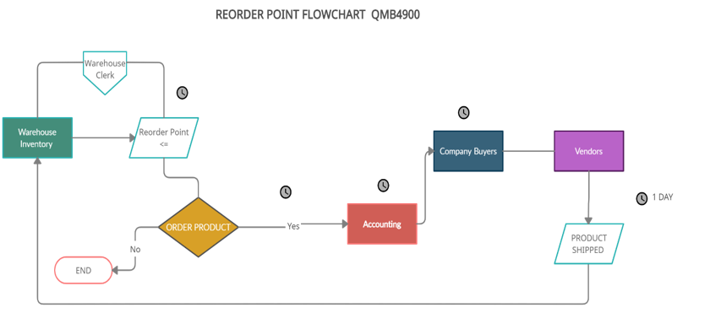
The only period we have through this process is the time it takes for the product to be shipped after the order is established from the warehouse clerk’s implementation of the reorder point.
Business Hypothesis:
- It could be applicable that the process itself plays a role in the bestselling products being on backorder.
- It could be possible the warehouse is experience inefficiencies or over ordering less-best-selling products being the case Super Shoppers has over amount of inventory that expires?
Business Intelligence:
After viewing the data, I was able to distinguish a few characteristics that facilitate the issues at hand. For this analysis we are going to look at the Weekly Inventories of all 10 stores and compare the gross number of products sold out to total average using Tableau. After reviewing the data, I seen there was no distinct date/time features aside from the 8-week blocks given the data. There for the issues we are trying to resolve will be based on product reorder point and stock.
- If fast selling products have a higher reorder point, I will have to lower it to meet demand and have an amount on stock or being ordered to prevent backorder.
- If overstocked products that are expiring this could mean reorder points are too low, there for over stocking products that do not sell efficiently
- I will also need to look at inventory amounts. Those with lower inventory amount may be best selling products running out. There for I will need to increase the stock amount.
- Again, if stock amounts are to high this could lead to overstock of products being ordered to soon during the reorder point.
First, I allocated all the data by combining all the store data to get an average visual of the products to tell which products were out of stock and those still in stock compared to those under a median range of 50%. I also added a summarized each individual table and made individual sheets for each store and each category of warehouse products which I combined in a story and dashboard while also using tables and descriptive statistics to verify the data.
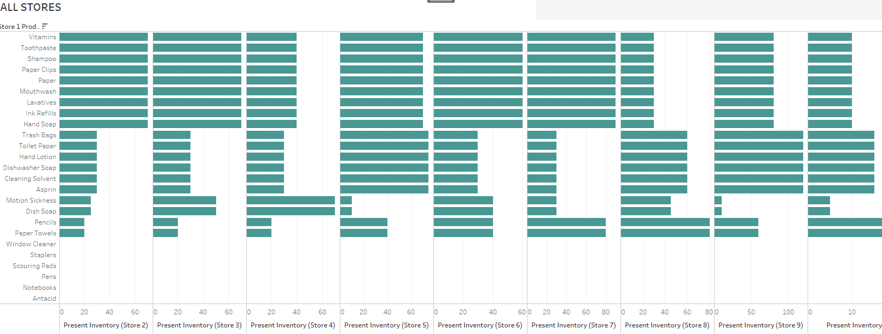
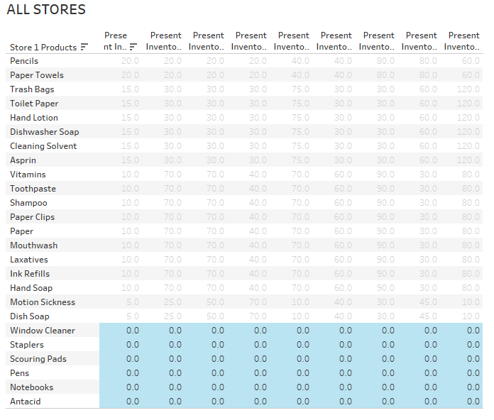
- We can see on average that window cleaner, staplers, scouring pads, pens, notebooks, and antacids are the products that are completely sold out this suggest they are most popular products.
- We can also see that Vitamins, toothpaste, shampoo, Paper clips, mouthwash, laxatives, ink refills and hand soap are still in stock from 75% to 100% not being sold as frequent.
- We can see that on average products like aspirin, Cleaning solvent, dishwasher Soap, hand lotion, are in stock at least 50% time or more.
The data also shows us that several stores are running out of products before other stores such as Store-2 and Store-4 with the least number of products in 8 weeks’ time period.
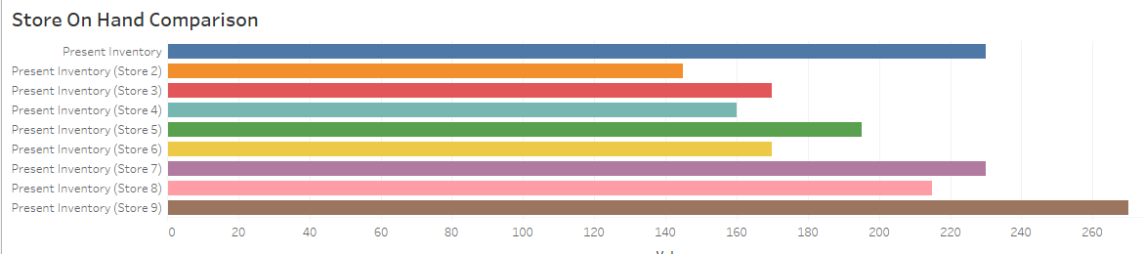
Store 2 data shows us product inventory from vitamins down at less than 5 products are left while products such as window cleaner and aspirin are completely gone and out of stock before the 8-week period.

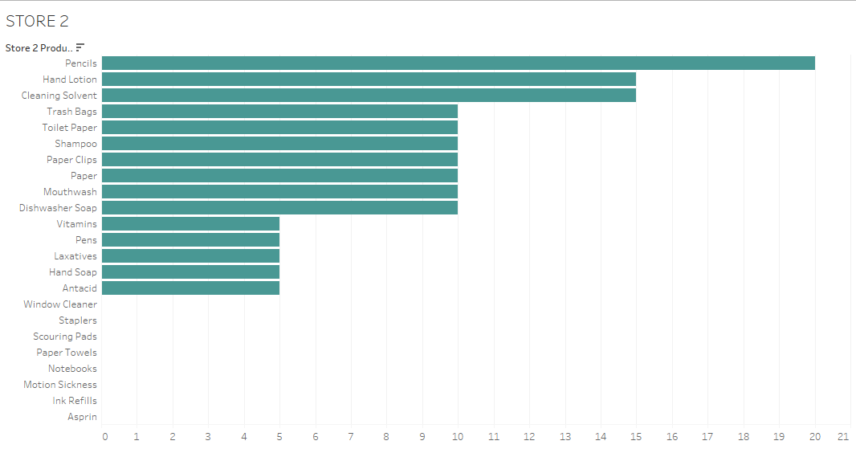
Store 2 descriptive statistics:
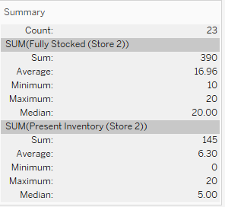
We can use the tree map to visualize the products which being sold out and other inventory at risk of being sold out in Store-2:
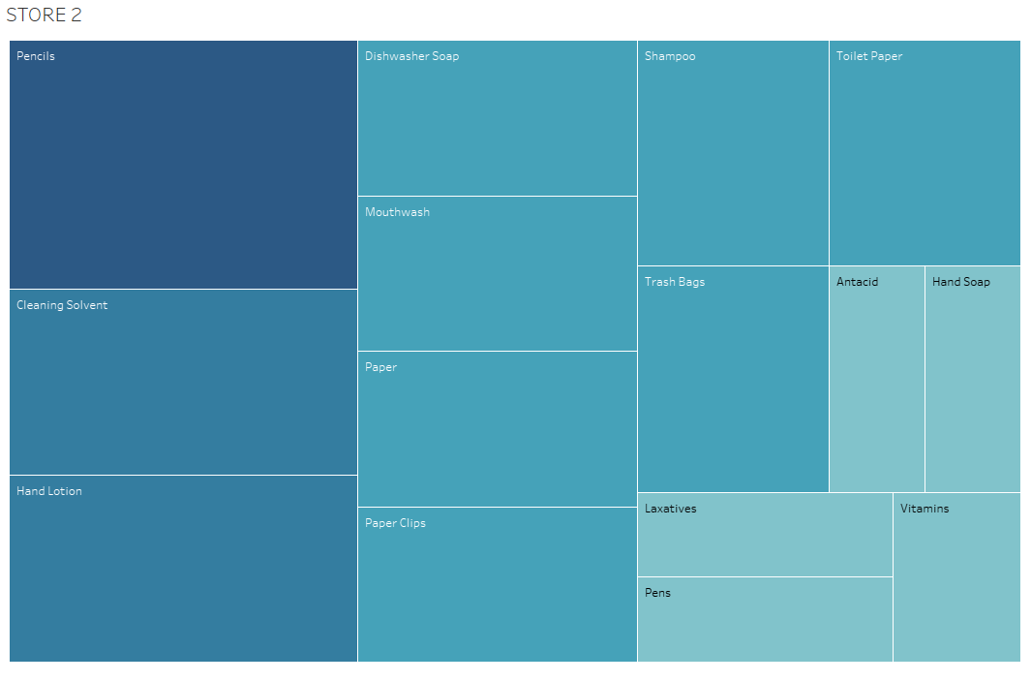
Pencils, Cleaning Solvent, and hand lotion are the most viable products. I assume these products are at risk of expiration. Even though it was never specified what types of products would have expiration dates such as non-food items and/or products.
From this data we now have a basis for which items to look at simply looking at sorted excel data we can see that in Store-2 by the end of week1 products such as Window cleaner, paper towels hand soap, motion sickness medicine, and ink refills are completely gone.
We can see that fully stocked window cleaner is at 20 items stocked. If this is how many stocked items sell in one week, I would recommend stocking 160 to 170 units and marking a reorder point at 50 % of the stock amount. This is based off summing the 20 product units are sold at a frequncy1 week times 8 weeks.
We can use this same principle for the other products in the store as well if we apply this estimate as follows.
 | Current Inventory | 8-week Inventory
Window Cleaner | 20 | 160
Paper Towels | 20 | 160
Toothpaste | 20 | 160
Hand Soap | 20 | 160
Toilet Paper | 20 | 160
Motion Sickness | 10 | 80
Ink Refills | 10 | 80

Super Shoppers also need to look at the distribution the orders sold out products take to go through the above process before the products are returned to the where house and available for new inventory. Unfortunately, we do not know the length of time Supper Shoppers takes to get the purchase order from the warehouse through accounting to the company buyer.
Super Shoppers can however look at the warehouse inventory to determine the amount of stock inventory and the reorder point. By changing the amount of stock items or the frequency for reorder point we could allocate a sufficient number of products to the store, so they do not run out. Also, we can look at the product which are nearly fully in stock in stores and determine if reorder point is ordering the less selling product more frequently than it should . This would reduce dimensionality of the warehouse and would save time in money on the front end of the business from being overstocked on product it does not sale that often.
I have broken down the warehouse inventory into the respected tables categories for specific products as follows.
- Bathroom Products
- Kitchen Products
- OTC Medicine
- Office products
Before making visualization, I cleaned the data and tabled it to work with and get valid results as follows.
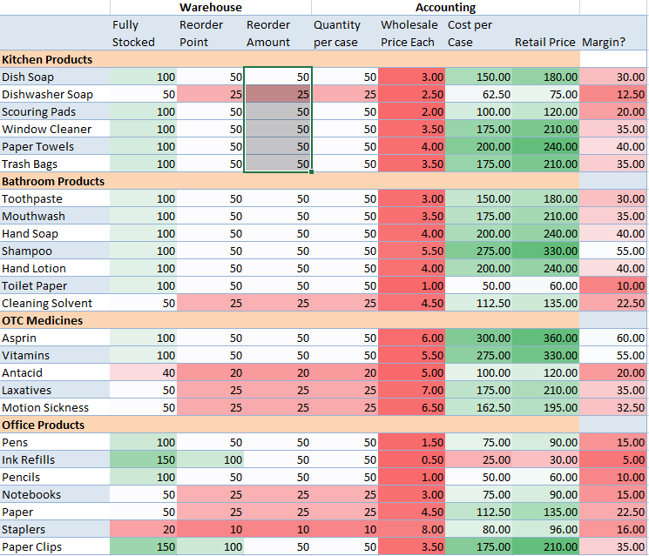
Why are slower selling products not being sold and reaching their expiration data?
This data shows us without visualization that Super Shoppers is keeping to much stock on products like pencils, ink refills, that do not sell that often when in fact Cleaning solvents sales at frequent amount while only having 50 units in stock. For ink refills once Super Shoppers get down to 100 units, they can order 100 more. This is inefficient, Super Shoppers could lower the stock and reorder point on other items as the visualizations show us such as pencils, and paper clips. Items most likely to expire would be OTC medicines food product, and some non-food products. I would recommend lowering the stock amount or raising the reorder point for those items plus toothpaste, mouthwash, laxatives, and shampoo. As these are products that are most likely to go to waste from over stocking
Why are we running out of best-selling products having to backorder stock of them?
We can see Super Shoppers is running out of bestselling products as mention because the reorder points are all too high at 100 or above while not facilitating enough stock to replenish the products before they run out within the 8 week period of time. These visualizations below of the warehouse categories and the chart data to come to this determination.
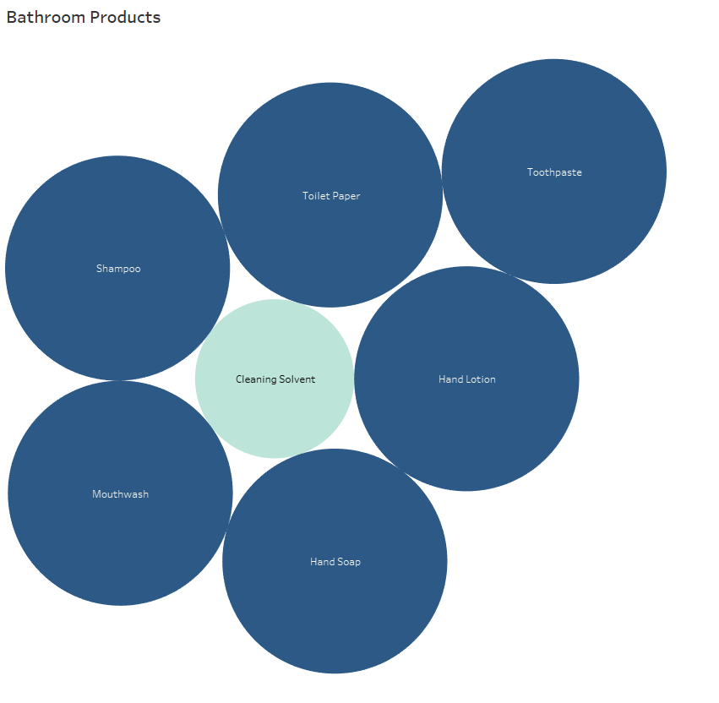

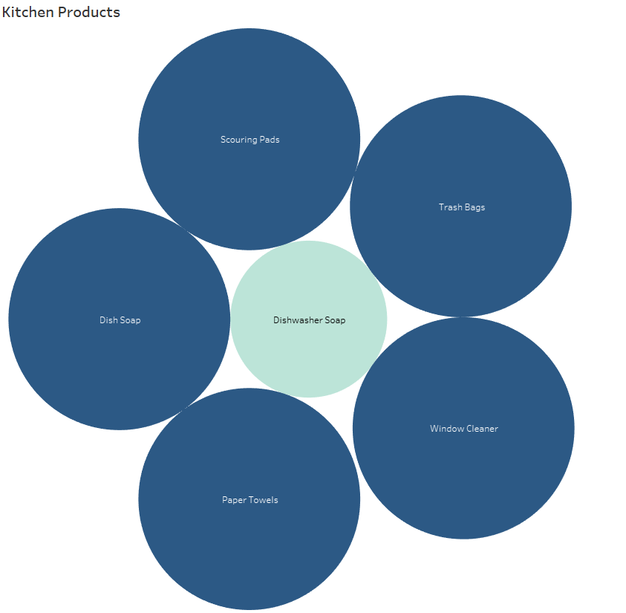

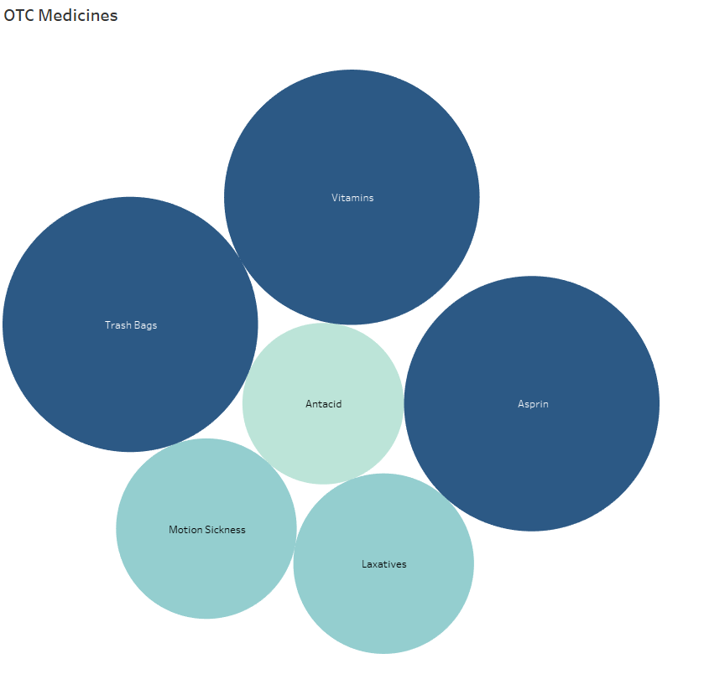

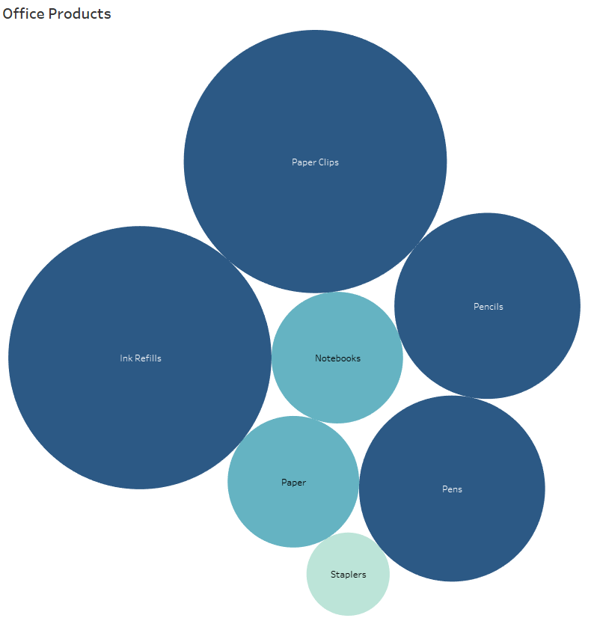

This data shows us that these specific products have a low reorder point compared to the reorder amount using packed bubble charts. We can see the variance between items have plenty of stock for and those compared to the same items that are running out of being short.
Essentially, Super Shoppers need to re-evaluate these items and adjust to number of products Super shoppers will have in stock to facilitate their demand for them. Also, lowering reorder points will allow for faster orders being procced so best-selling products are always on hand. Again, I will mention I have no distinct timeline as to the completion or estimate of the process as specified in the flowchart. This could very well be an internal problem, but there is no way to tell without the data.

Course Project - Point of Sale Case Study
Supper Shoppers Store sales analysis report will seek to answer several business questions in relation to individual and combined data analysis per the 10- Supper Shopper store locations. I had to re-modify my dataset by formatting headers and cleaning my data(dataset-attached). I then added new calculations and metrics to be used after adding the 2 datasets of store data and warehouse data together using python to create a data frame and output extra columns to use create data for several new key metrics relative to business questions that need answered. I then created several new tables to derive business intelligence as outlined below.
Insights used will be to identify:
- Keeping the shelves stocked and best-selling products on hand
- Identifying Inventory Management flaws
- Reducing cost and overhead with overstocked inventory
- Inventory Patterns
This analysis and visualizations report is broken down into categories based off the individual store per location and combined data used to answer specific business questions to provide insights. This report will initially start with the final analysis and recommendations facilitating the insights as noted characterized above in Analysis Report Index.
Analysis Report Index:
- Business Questions
- Final Analysis (Business Intelligence)
- Recommendations
- Super Shopper Store Analysis (Store 1 Through 10)
Business Questions:
In order to establish sound metrics understanding the dataset, revealing specific metrics that will allocate answering or profound questions that are essential to understanding the issues Super Shoppers is currently facing. The questions posed below need to be answered with data. I have outlined the questions and description of each question in reference to how it will provide business intelligence.
- Which products are running out of stock first per store
- How frequently are stores running out products
- Which products are not selling
- Does the amount of stock inventory needed to facilitate Reorder Point facilitate the demand of inventory per store
- What are the average products needed per store
- What is the profit loss based on the current inventory threshold
- What is the average Inventory value
- Regression Analysis of Profit and Loss of sales
To best answer these questions I have implemented a data workflow to facilitate new metrics based on calculations to provide information on Inventory Turnover, (RIO) Return On Investment, Sell-Through-Rate, Sales Velocity, Margins Per Product Unit, Sale Price With Margin Cost, Average Sales, Per Week, Per Store, Per Product, Average Inventory Values, Individual Store Profit & Loss Regressions.
Description of Metrics:
- Return on investment (ROI) is a ratio used to determine a business’s profitability. It is calculated by taking your net profit and dividing it by the cost of the investment.
- Implement X and Y Values to develop simple linear regression using Store Profit and Loss summations.
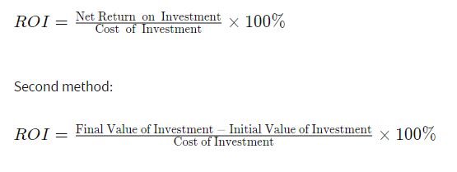
- Inventory “turnover” is a measure of how often a business sells through its entire inventory in a set period of time (often a year). In our case 8 weeks; I then calculated it by dividing the total sales by the average inventory value or cost of goods sold. these calculations also had to be discovered with new metrics inside the data.
- Sell-through rate is a calculation that is used to measure the amount of product received from Super Shoppers manufacturer against the amount of product sold to your customers in a specified period of time. To calculate it, using the total sales and divide that number by the stock on hand. Multiply this number by 100 to convert it to a percentage.
- Sales velocity is a way to measure how fast Super Shoppers products sell when they are available to thier customers. By multiplying the number of potential customers in a given period of time by the average selling price of a product and customer conversion rate, then divide that number by the average length of time it takes for a customer to convert. To calculate the Customer conversion rate. I took an averaged total of the number of products sold per week. These products sold where in fact customers; the conversion rate is the number of conversions divided by the total number of visitors.
Final Analysis (Business Intelligence)
Based on the given data from each store I was able to extract and analyze specific business information and trends as follows. This is an overall look at the stores combine. All the individual store data is listed below in the respected section analyzed for each store.
Top Selling Products:
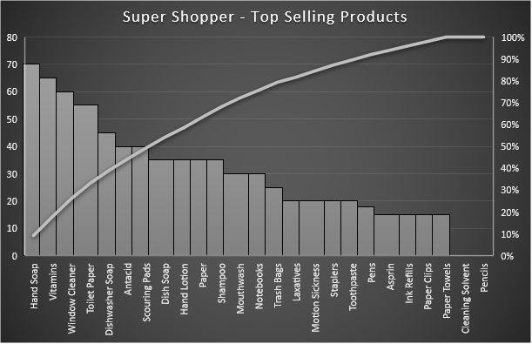
The distribution above shows the calculations of inventory sold for each Super Shoppers Store. The data shows us that the following are the top selling items across all stores over 8 week period of time as per the dataset provides.
- Hand soap
- Vitamins
- Window Cleaner
Top 3 Products Most Out of Stock
I had to use separate calculations and distribution to find out how many items in stock sold each week while retaining the original amount by counting the times stock ran out and = 0, then calculated the difference to find out exactly how much inventory was sold from the original full Stock column of data then cross referenced the data with distributions of warehouse inventory which corelated with the margins and reorder units values.
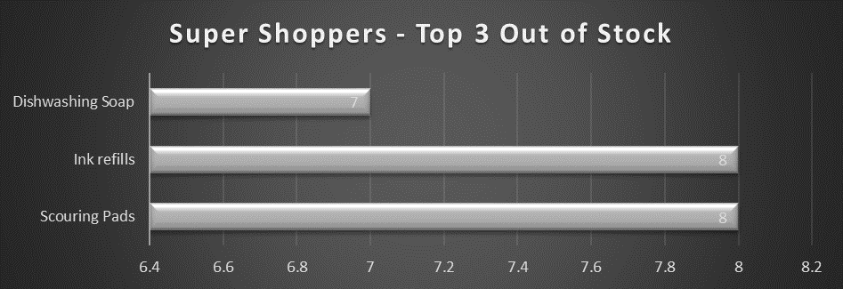
Out of Stock Product Frequency
The out of stock data shows combined analysis which shows the products which frequency is most out of stock. This analysis revels business intelligence about the inventory management used by Super Shoppers answering several business questions.
- We can see that reorders need to be more frequent,
- That warehouse inventory amounts need to be increased
- That the instore inventory amounts need to be increased
- Outliers & Errors
- Poor management due from bad inventory systems and communications from the warehouse and stores individually.
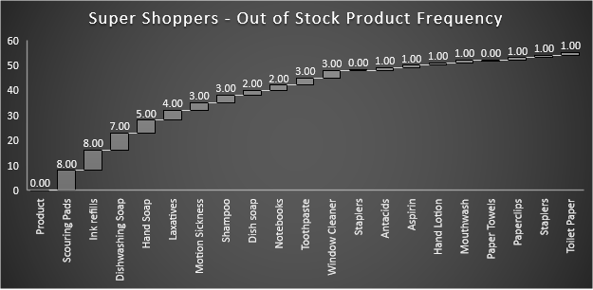
Lest-Sold Products:
These products across all stores had issues of overs Stocking. There are 2 main products where across each store stock was full products never sold. Products that never sell can be dead weight and cost Super shoppers in overhead, storage, and management.
Understanding which products are not producing margins for company can help Supers Shoppers optimize their inventory managements practices, overhead and overall operations. These metrics will show how products sitting on the shelf expiring could be caused to backlogged inventory and non-profitable items.
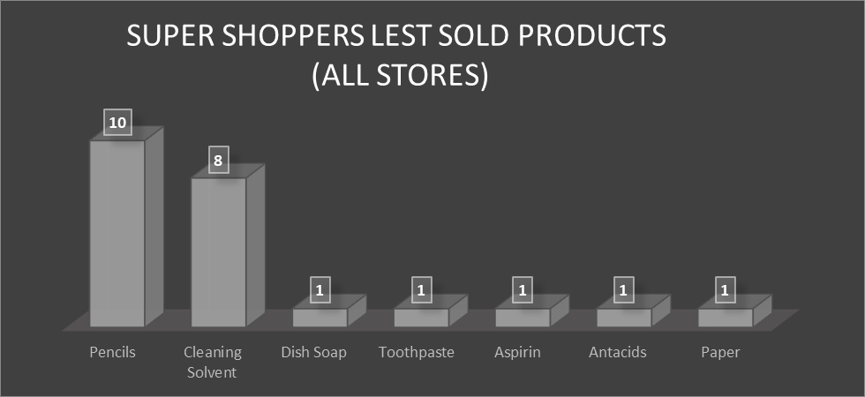
- Pencils – I would recommend discontinuing this product if trends over full year and normal distribution of appropriate time series (i.e. years, months…). This time series data was not available other than the 8-week intervals provided in the dataset.
- Cleaning Solvent - without time series data I cannot accurately recommend Discontinuing this product. Given the dataset, some products did sale. I would recommend implementing new Inventory management systems and raise the threshold for reorder point while lowering the storage amount in the warehouse to at least 50% of the current product inventory amounts.
- Dish soap, Toothpaste, Aspirin, Antacids, and Paper inventory products seem to be full but dd have a fair distribution of sale in other stores other than were the data points where acquired. I belive mismanagement and insufficient systems, practices, and processes are cause for overstock issues with these products and those related. Please see recommendations below
Product Recommendations:
Based off the analysis I used the distribution data to find the median average amount of products need per week across all stores to facilitate good product inventory amount and keep up with customer demand.
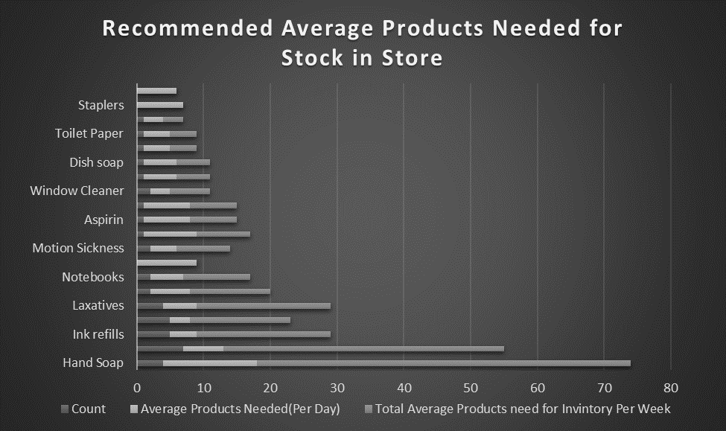
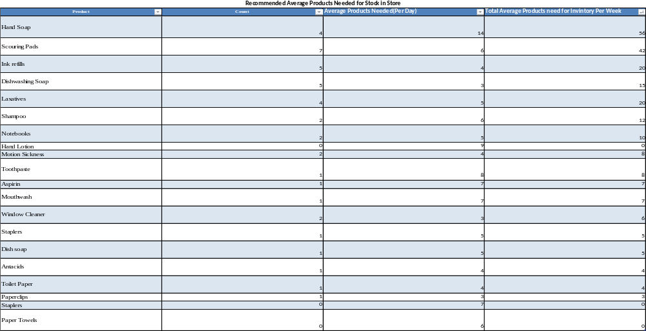
Recommendations Analysis:
To achieve these goals, I highly recommend implementing these strategies based off the data Provided above.
- Defining minimum ordering quantity for all listed products that will facilitate the average basis of sales forecasted in the Analysis
- Increase the reorder point for specific products that average a loss from being out of stock to soon.
- Drop Specific Products from inventory or keep minimum at hand with higher reorder point.
- Rising cost of best-selling products to increase the margin while lowering the reorder point to implement product replenishment.
- Allocate more fully stocked products on-hand for best sellers per store.
- Daily inventory assessment and analyzing processes.
- Using systematic inventory management techniques such as or to manage.
- Training staff to use the technology and inventory management tools. Such as (SAM) Software Asset Management Software (Gartner Peer Insights, 2020).
- Training staff to use the technology and inventory management techniques. Such as lean process, scheduled meetings, establishing KPI’s Categorize Your Inventory Using ABC Analysis hierarchy, Implement Reorder Point Formulas, Just-in-time system, or Kanban system (DEAR Systems, 2017), (Systems, 2017).

- Arranging Individual stores based of customer preference. Keep bestselling products in the front of the store, Stack inventory higher making better use of vertical spaces and end-caps (Fdm4, 2020).
- Implementing lean principles while Maintaining the 5'S' in stores; Sort, Set in order, Shine, Standardize, and Sustain (5S Today, 2020).
Super Shoppers 10 Store Individual Analysis:
The below store analysis are detailed tree maps and descriptive statistics that reveal outliers and show trends in the current data per store. Each store has business questions answered individually. While being summarized in the above final analyses
Store 1 Analysis:
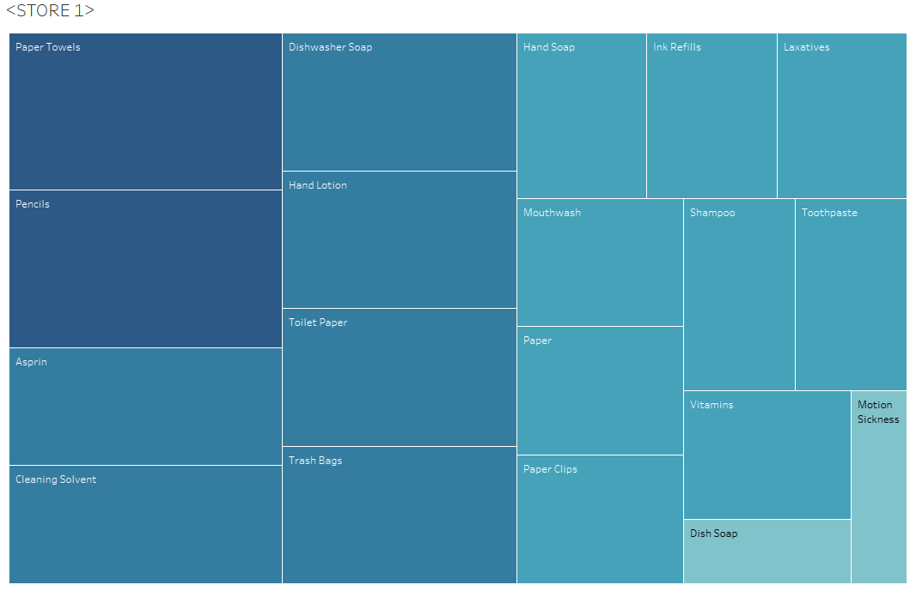

Store 1 Data Analysis:
Errors:
In week 6 in Store 1 an error occurred for the inventory product Aspirin. Inventory showed fully stocked amount to be 20 compared to the inventory value 120 in week 6. Because the data shows week 5 inventory was down to 5 units I belive 15 units where ordered for the following week and this is just a data entry error.
Highest selling products:
Over the past 7 weeks to present these top products sold out the most and where not in stock
Product | Stock Amount | #Weeks Sold out | Product Avg (Needed Per Week) | Analysis
Staplers | 10 | 5 | 6.7 | Increase Stock Amount and reorder point
Motion Sickness | 10 | 3 | 5.0 | Increase Stock Amount and reorder point
Ink refills | 10 | 4 | 5.0 | Increase Stock Amount and reorder point
Dishwasher Soap | 15 | 4 | 9.1 | Increase Stock Amount and reorder point
Hand Soap | 20 | 4 | 13.9 | Increase Stock Amount and reorder point
Notebooks | 15 | 3 | 8.9 | Increase Stock Amount and reorder point

I recommend increasing the stock amount to double all products by 50% or the calculated product average above. to meet the demand.
Also, follow recommendations and best practices I have outlined in the recommendations section of the analysis above. I belive the warehouse needs to adjust its reorder points for these products per this store schedule. The store should implement product placement and staging strategies to facilitate increasing profit margin through demand and visibility. I would also recommend instore management check to see if sound inventory management and tracking processes are being conducted correctly.
Product Average = Average of All sales divided by each week minus the full stock amount times 100 percent.
Lowest selling products:
Product | Stock Amt | Sold (8weeks) | Product Avg (Needed Per Week) | Analysis
Pencils | 20 | 0 | 0% | Remove product from store or reduce stock Amount to 5 and resell point by 75%
Cleaning Solvent | 15 | 3 | 0% | Reduce Stock Amount to 10 and reorder point by 50%
Product Profit and Loss
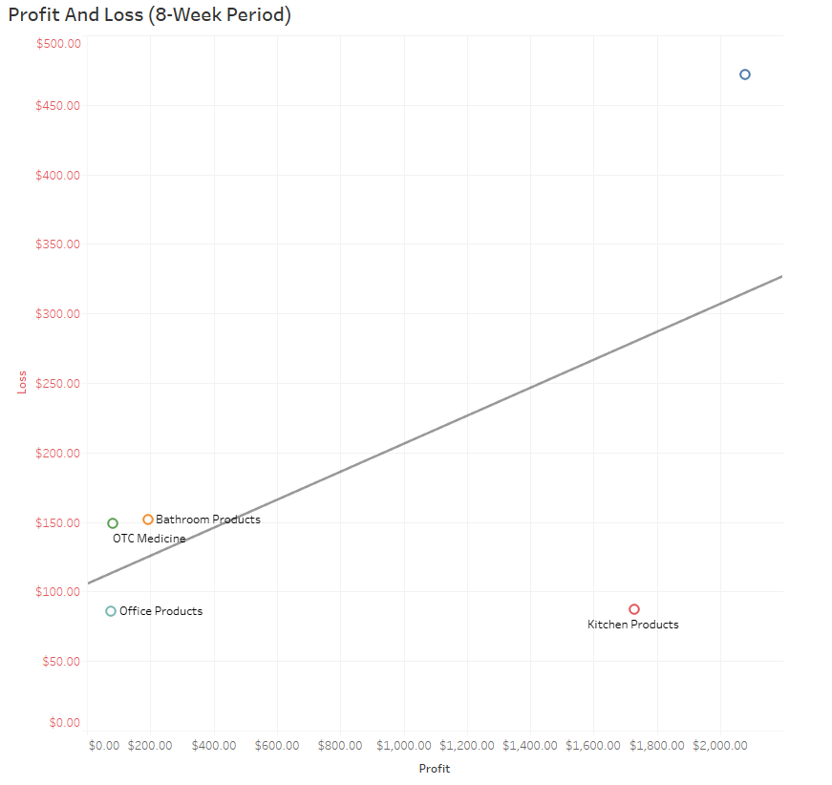
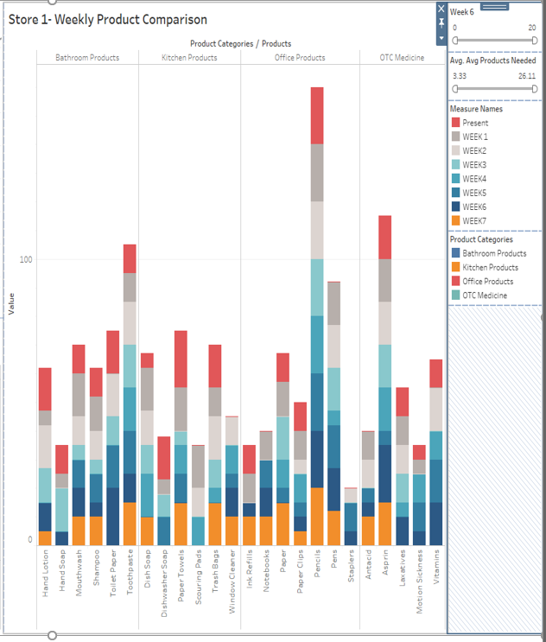

Average Products Sold per Week
Here are the store averages based in percentages of sales per week(8-weeks)
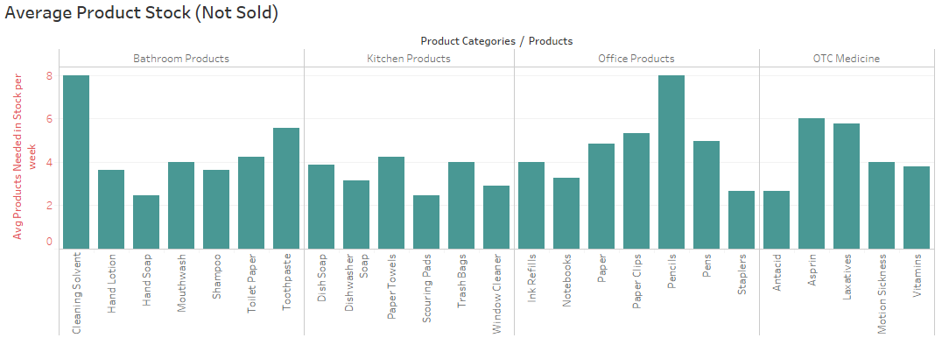
Inventory Turn Over:
This is the measure of how often Super Shoppers Store 1 sells through its entire inventory in a set period of 8 weeks. By dividing the total sales by the average inventory value
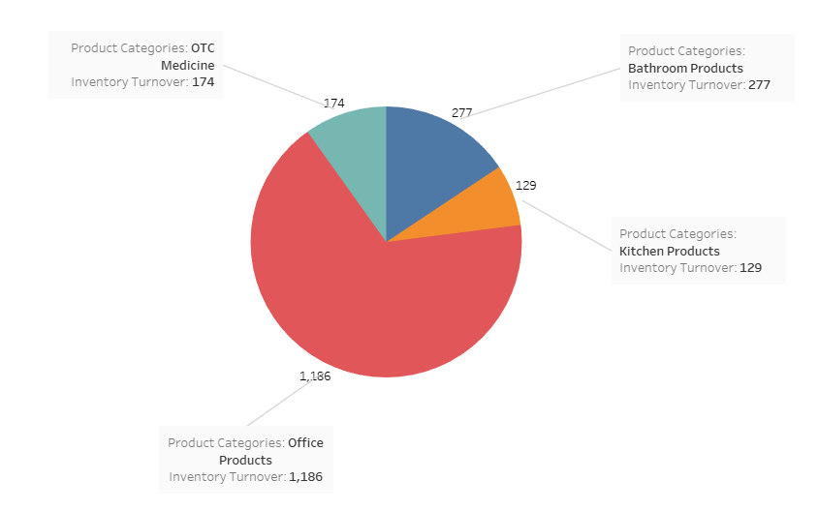

Sell Through Rate:
Sell-through rate is a calculation that is used to measure the amount of product received from your manufacturer against the amount of product sold to your customers in a specified period of time.
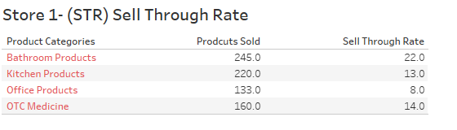
Store 2 Analysis:
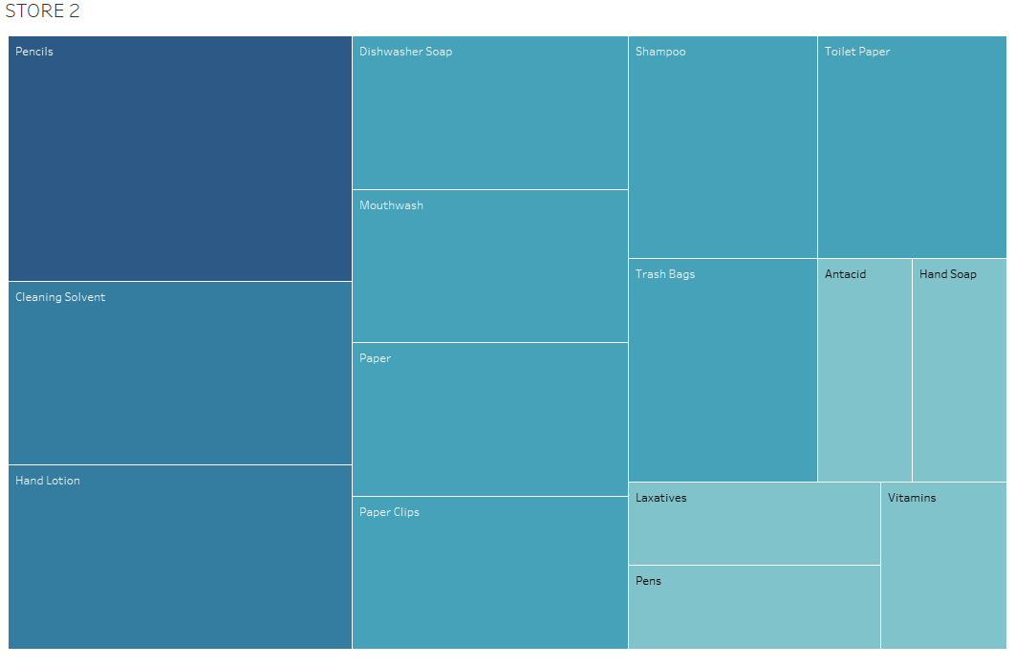
Store 2 Data Analysis:
Errors:
- In week 6 in Store 2 an error occurred, or wrong reorder amount of hand soap was logged at 50 units. This could be a hum error or possible software issue. Full stock Amount should be 20.
- Week 17 products where completely out of stock. Re-order warehouse amount only sent 10 to 15 units when fully stocked inventory at this location needs to be 20 units. There is not enough product being sent to stock this store.
Store 2 Highest selling products:
Over the past 7 weeks to present these top products sold out the most and where not in stock
Product | Stock Amount | #Weeks Sold out | Product Avg (Needed Per Week) | Analysis
Ink refills | 10 | 5 | 3 | Increase Stock Amount and reorder point
Motion Sickness | 10 | 2 | 5 | Increase Stock Amount and reorder point
Toilet Paper | 20 | 2 | 7 | Increase Stock Amount and reorder point
Hand Soap | 20 | 2 | 11 | Increase Stock Amount and reorder point
Toothpaste | 20 | 2 | 10 | Increase Stock Amount and reorder point
Paper Towels | 20 | 2 | 6 | Increase Stock Amount and reorder point
Window Cleaner | 20 | 3 | 3 | Increase Stock Amount and reorder point

I recommend increasing the stock amount to meet the demand especially for Ink refills and Motion Sickness medicine. I recommend that the warehouse reorder point be dropped to a less amount to cover the demand of the listed products.
Also, follow recommendations and best practices I have outlined in the recommendations section of the analysis above. The store should implement product placement and staging strategies to facilitate increasing profit margin through demand and visibility. I would also recommend instore management check to see if sound inventory management and tracking processes are being conducted correctly.
Product Average = Average of All sales divided by each week minus the full stock amount times 100 percent.
Store 2 Lowest selling products:
Product | Stock Amt | Sold (8weeks) | Product Avg (Needed Per Week) | Analysis
Pencils | 20 | 0 | 20 | Remove product from store or reduce stock Amount to 5 or increase resell point by 75%
Dish Soap | 15 | 3 | 9.25 | Reduce Stock Amount to 10 and reorder point by 50%

Store 2 Product Profit and Loss:
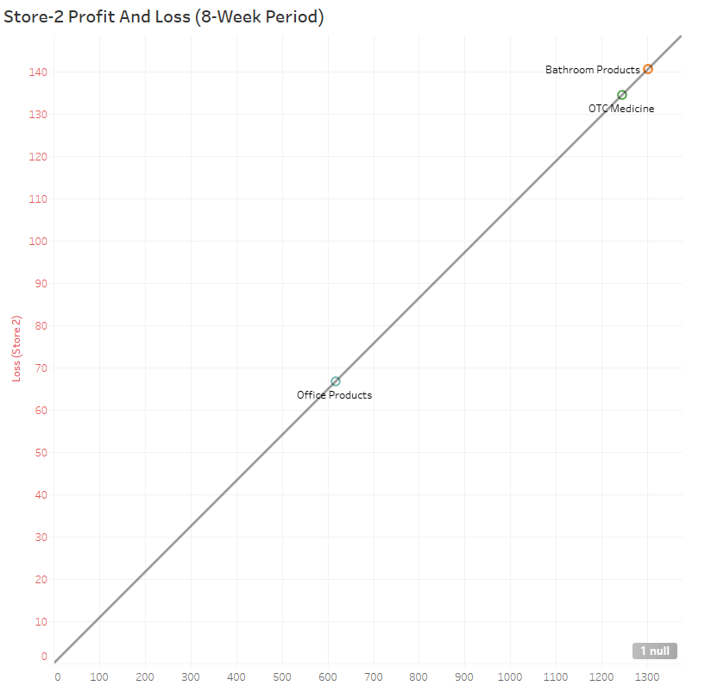
Store 2 Average Products Sold per Week
Here are the stores average percentages of sales per week
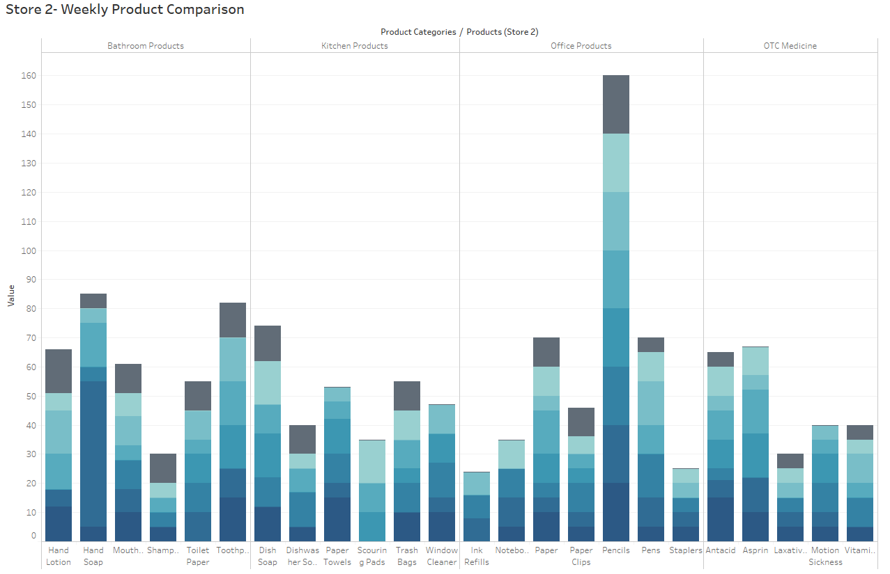
Store 2 Inventory Turn Over:
This is the measure of how often Super Shoppers Store 1 sells through its entire inventory in a set period of 8 weeks. By dividing the total sales by the average inventory value
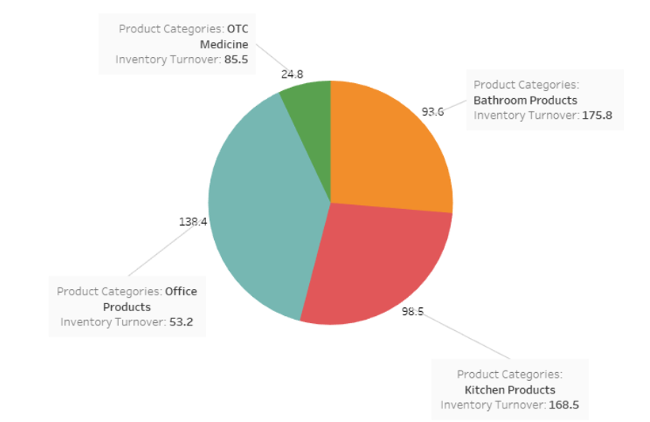

Store 2 Sell Through Rate:
Sell-through rate is a calculation that is used to measure the amount of product received from your manufacturer against the amount of product sold to your customers in a specified period of time.
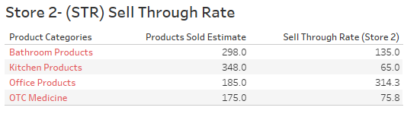
Store 2 ROI:
Return on investment based on calculating the profit made divided by the initial cost of products purchased in inventory:
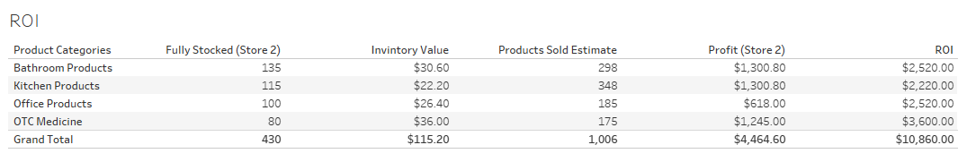
Store 3 Analysis:
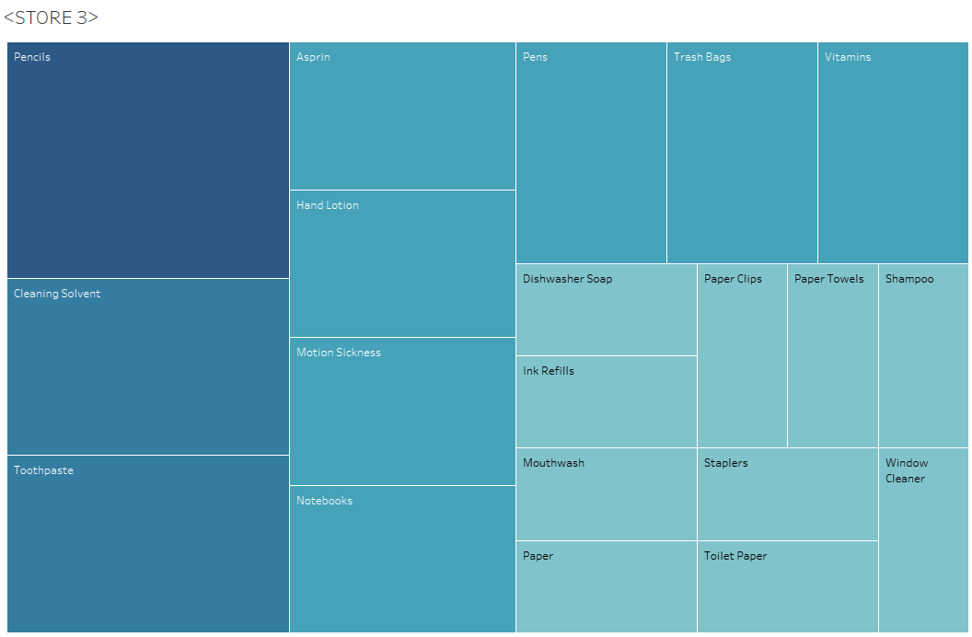
Store 3 Data Analysis:
Errors:
Store 3 Did not seem to have many errors, products inventory amounts seemed to suffice the demand. Only on a few occasions mentioned below did products sell out and where out of stock for more that 1-4 weeks.
Store 3 Highest selling products:
Over the past 7 weeks to present these top products sold out the most and where not in stock
Product | Stock Amount | #Weeks Sold out | Product Avg (Needed Per Week) | Analysis
Dish soap | 20 | 3 | 5.25 | Increase Stock Amount and decrease reorder point
Toothpaste | 20 | 3 | 7.5 | Increase Stock Amount and decrease reorder point
Scouring Pads | 20 | 4 | 4.3 | Increase Stock Amount and decrease reorder point

I recommend increasing the stock amount to meet the demand especially for Dish soap and Toothpaste, and Scouring Pads I recommend that the warehouse reorder point be dropped to a less amount to cover the demand of the listed products.
Also, follow recommendations and best practices I have outlined in the recommendations section of the analysis above.
Product Average = Average of All sales divided by each week minus the full stock amount times 100 percent.
Store 3 Lowest selling products:
Product | Stock Amount | #Weeks Sold out | Product Avg (Needed Per Week) | Analysis
Pencils | 20 | 0 | 20 | Decrease or cancel Stock Amount and reorder point
Cleaning Solvent | 15 | 0 | 15 | Decrease Stock Amount and reorder point

Store 3 Product Profit and Loss:
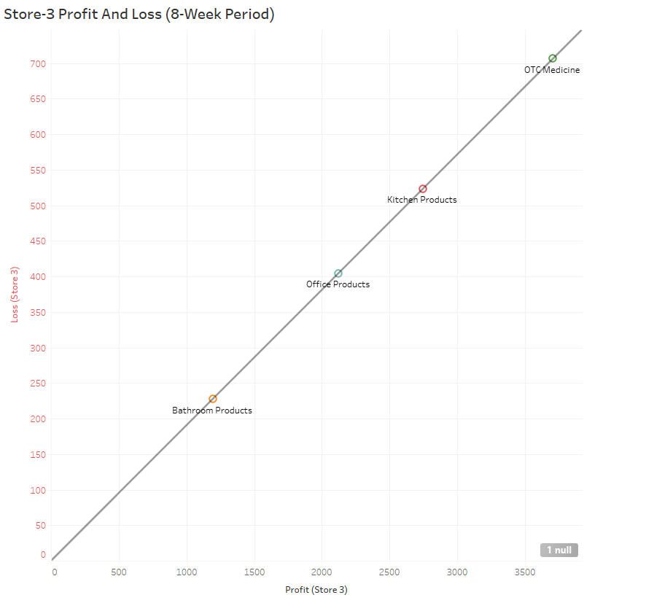
Store 3 Average Products Sold per Week
Here are the store averages based in percentages of sales per week(8-weeks)
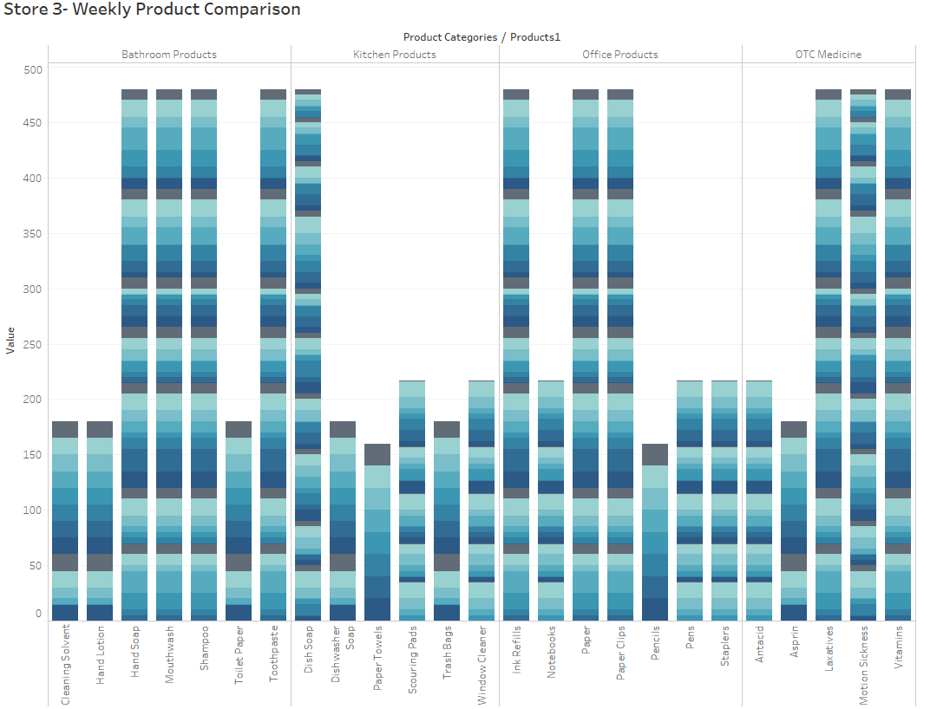
Store 3 Inventory Turn Over:
This is the measure of how often Super Shoppers Store 1 sells through its entire inventory in a set period of 8 weeks. By dividing the total sales by the average inventory value
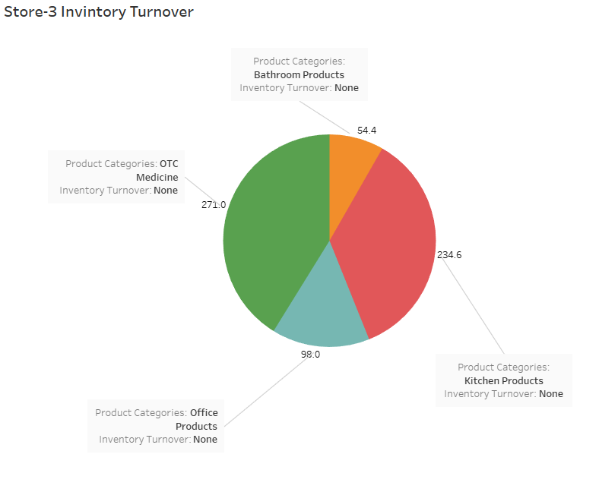

Store 3 Sell Through Rate:
Sell-through rate is a calculation that is used to measure the amount of product received from your manufacturer against the amount of product sold to your customers in a specified period of time.
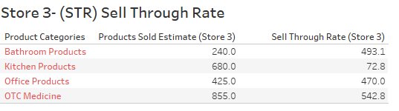
Store 3 ROI:
Return on investment based on calculating the profit made divided by the initial cost of products purchased in inventory:
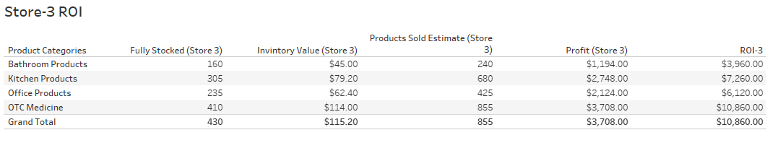
Store 4 Analysis:
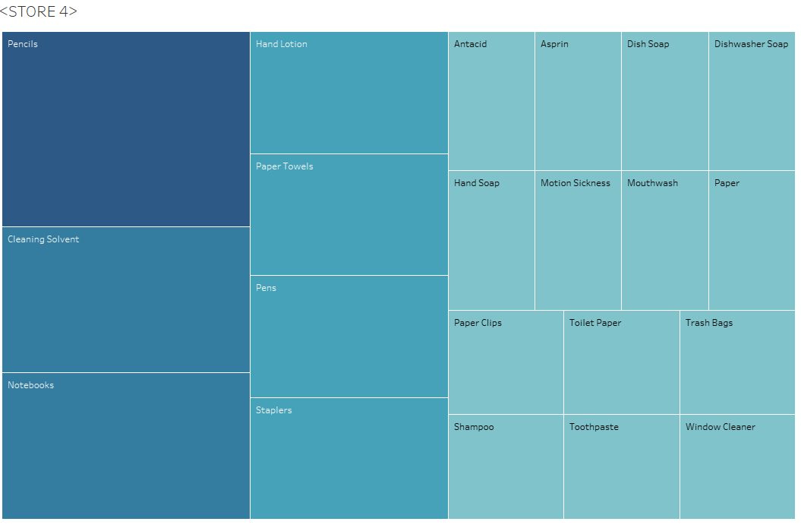
Store 4 Data Analysis:
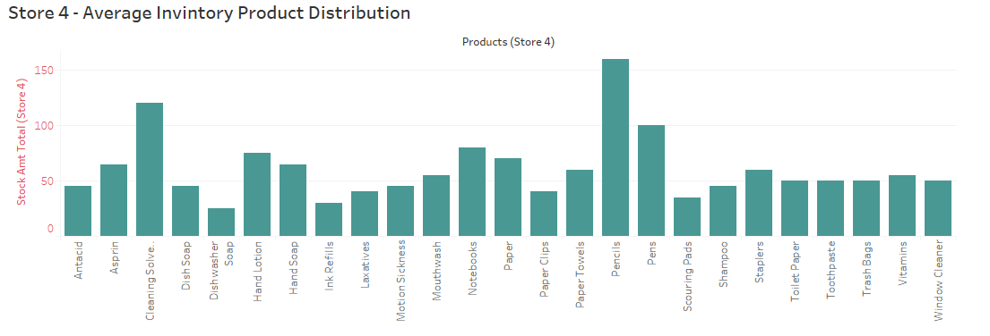
Errors:
- In week 6 We see that hand Office Products and Bathroom Products are completely out of stock, only receiving partial reorders of 5 products each the following week. This suggest the warehouse reorder point does not facilitate the demand for these 13 Products
- Again, as seen in store 1,2, and 3 I have noticed a trend with scouring pads being out of stock from week 5 to week 8(present). This suggest ether the warehouse needs to raise the stock amount and lower the reorder point. It could also suggest the internal inventory management process at each location is faulty and needs a new implementation using new systems.
- Again, as seen in store 1,2, and 3 I have noticed a trend with Pencils are not selling at all. This suggest the product is ineffective and non-profitable.
- Week 3 Window cleaner, trash bags, toothpaste, shampoo, toilet paper, notebooks, dishwasher soap, and ink refills are sold out. Only receiving minimum of 5 units the following completely sold out on week 5
- It appears that the reorder amounts(all Products) being distributed for each product by 5 units per week when on schedule.
Store 4 Highest selling products:
Over the past 7 weeks to present these top products sold out the most and where not in stock
Product | Stock Amount | #Weeks Sold out | Product Avg (Needed Per Week) | Analysis
Ink refills | 10 | 3 | 4 | Increase Stock Amount and reorder point
Dishwasher Soap | 15 | 3 | 3 | Increase Stock Amount and reorder point
Scouring Pads | 20 | 4 | 4 | Increase Stock Amount and reorder point
Shampoo | 20 | 3 | 6 | Increase Stock Amount and reorder point
Laxatives | 10 | 3 | 5 | Increase Stock Amount and reorder point
Hand Lotion | 20 | 3 | 9 | Increase Stock Amount and reorder point

I recommend increasing the stock amount to meet the demand especially for Scouring Pads, Shampoo, and Hand Lotion. I recommend that the warehouse reorder point be dropped to a less amount to cover the demand of the listed products.
Also, follow recommendations and best practices I have outlined in the recommendations section of the analysis above.
Product Average = Average of All sales divided by each week minus the full stock amount times 100 percent.
Store 4 Lowest selling products:
Product | Stock Amt | Sold (8weeks) | Product Avg (Needed Per Week) | Analysis
Pencils | 20 | 0 | 20 | Remove product from store or reduce stock Amount to 5 or increase resell point by 75%
Cleaning Solvent | 15 | 0 | 15 | Reduce Stock Amount to 10 and reorder point by 50%

Store 4 Product Profit and Loss:
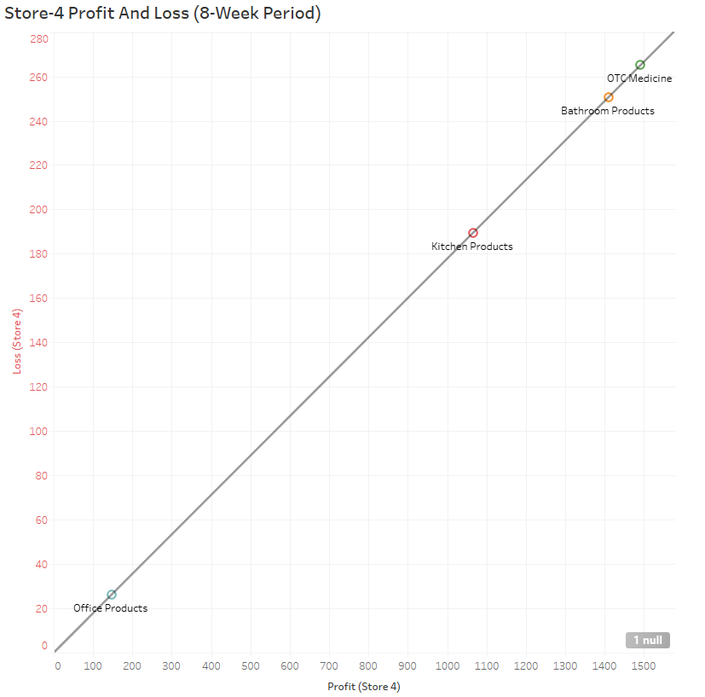
Store 4 Average Products Sold per Week
Here are the store averages based in percentages of sales per week(8-weeks)

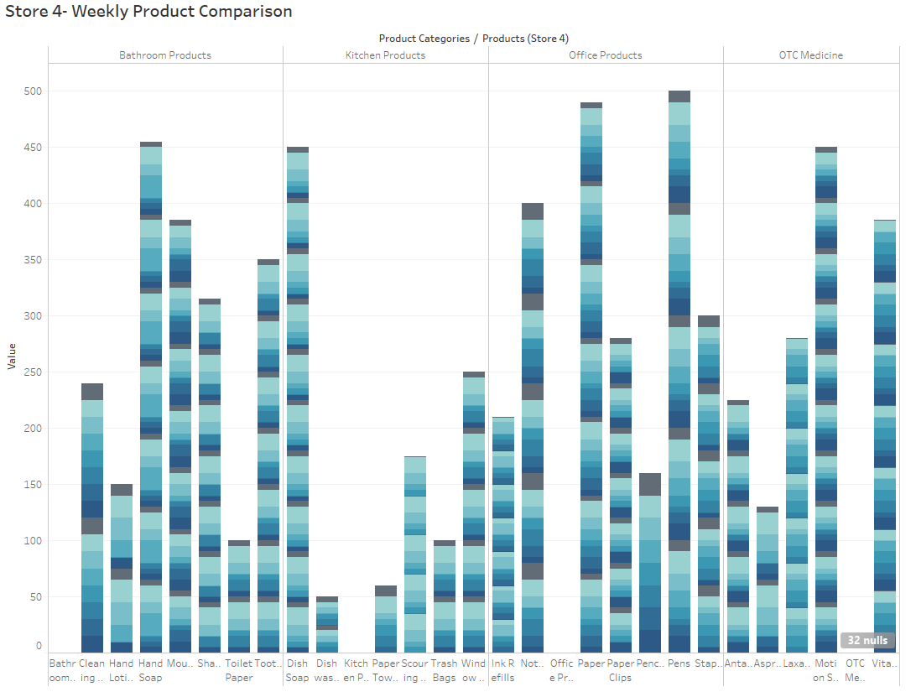
Store 4 Inventory Turn Over:
This is the measure of how often Super Shoppers Store 1 sells through its entire inventory in a set period of 8 weeks. By dividing the total sales by the average inventory value
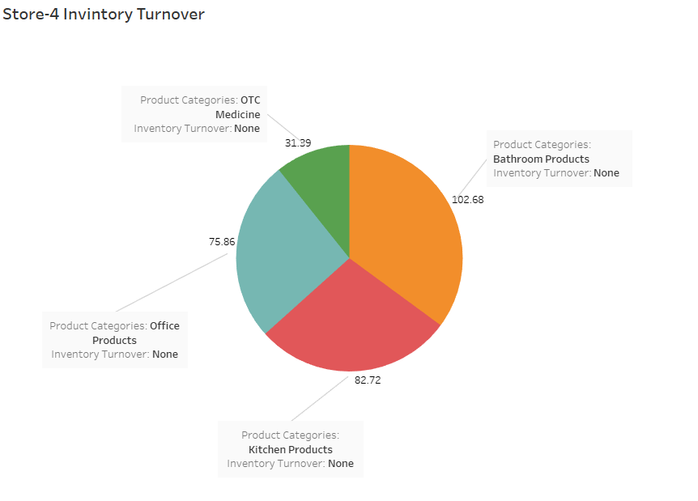

Store 4 Sell Through Rate:
Sell-through rate is a calculation that is used to measure the amount of product received from your manufacturer against the amount of product sold to your customers in a specified period of time.
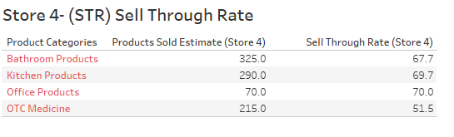
Store 4 ROI:
Return on investment based on calculating the profit made divided by the initial cost of products purchased in inventory:
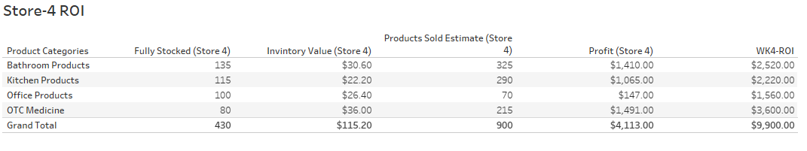
Store 5 Analysis:
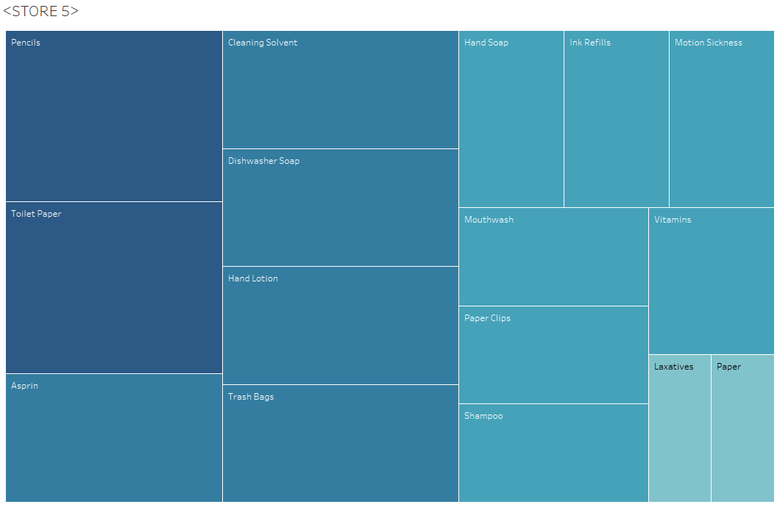
Store 5 Data Analysis:
Errors:
- In week 5 in Store 5 Scouring Pads follow the trend going unordered for 4 weeks out of stock.

Store 5 Highest selling products:
Over the past 7 weeks to present these top products sold out the most and where not in stock
Product | Stock Amount | #Weeks Sold out | Product Avg (Needed Per Week) | Analysis
Scouring Pads | 20 | 5 | 4
Ink refills | 10 | 4 | 4 | Increase Stock Amount and reorder point
Hand Soap | 20 | 4 | 4 | Increase Stock Amount and reorder point
Staplers | 10 | 4 | 5 | Increase Stock Amount and reorder point
Notebooks | 15 | 4 | 5 | Increase Stock Amount and reorder point
Dishwashing Soap | 15 | 4 | 5 | Increase Stock Amount and reorder point
Motion Sickness | 10 | 3 | 4 | Increase Stock Amount and reorder point

I recommend increasing the stock amount to meet the demand especially for All products listed above that go more than 3 weeks without replenishing store 5 inventory. I recommend that the warehouse reorder point be dropped to a less amount to cover the demand of the listed products.
Recommendations Store 5:
- Increase sold out product reorder point by 5 units doubling the units being sent to 10 units per week on average.

Also, follow recommendations and best practices I have outlined in the recommendations section of the analysis above. The store should implement product placement and staging strategies to facilitate increasing profit margin through demand and visibility. I would also recommend instore management check to see if sound inventory management and tracking processes are being conducted correctly.
Product Average = Average of All sales divided by each week minus the full stock amount times 100 percent.
Store 5 Lowest selling products:
Product | Stock Amt | Sold (8weeks) | Product Avg (Needed Per Week) | Analysis
Pencils | 20 | 0 | 20 | Remove product from store or reduce stock Amount to 5 or increase resell point by 75%
Cleaning Solvent | 15 | 0 | 15 | Reduce Stock Amount to 10 and reorder point by 50%
Toothpaste | 20 | 0 | 13 | Reduce Stock Amount to 10 and reorder point by 50%
Aspirin | 20 | 0 | 13 | Reduce Stock Amount to 10 and reorder point by 50%

Store 5 Product Profit and Loss:
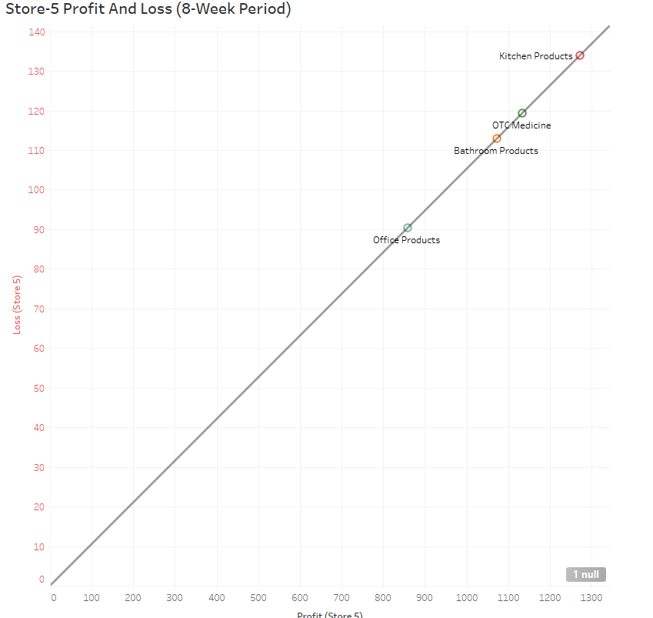
Store 5 Average Products Sold per Week
Here are the stores average percentages of sales per week.
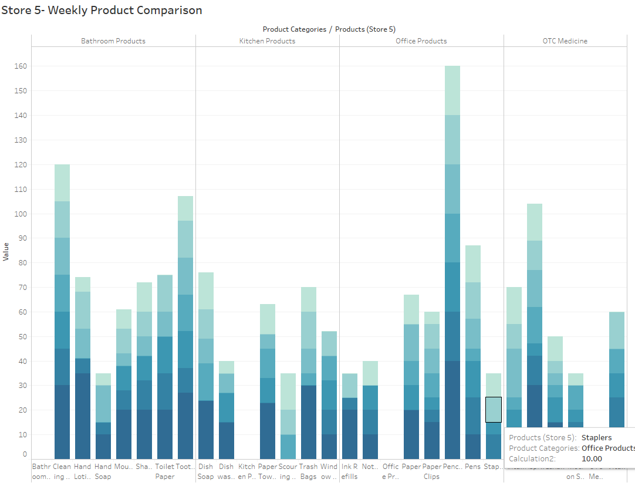
Store 5 Inventory Turn Over:
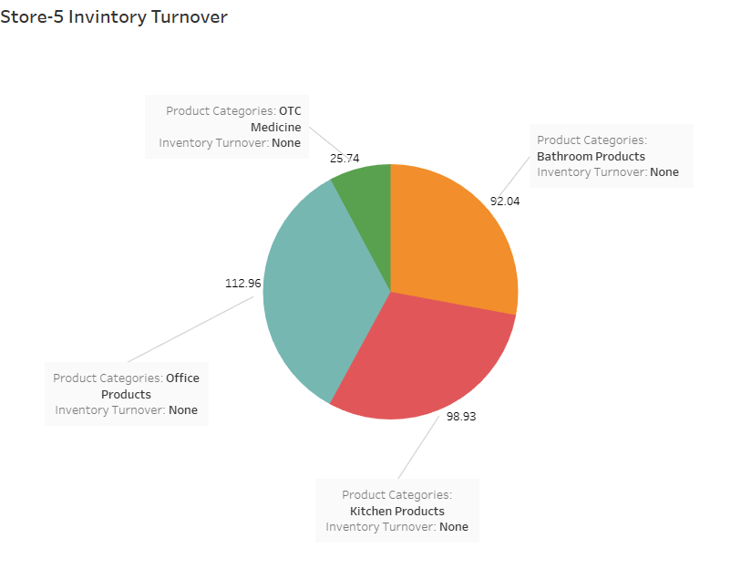
This is the measure of how often Super Shoppers Store 1 sells through its entire inventory in a set period of 8 weeks. By dividing the total sales by the average inventory value
Store 5 Sell Through Rate:
Sell-through rate is a calculation that is used to measure the amount of product received from your manufacturer against the amount of product sold to your customers in a specified period of time.
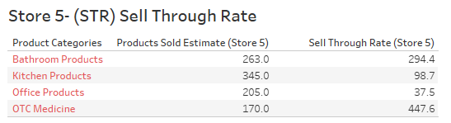
Store 5 ROI:
Return on investment based on calculating the profit made divided by the initial cost of products purchased in inventory:
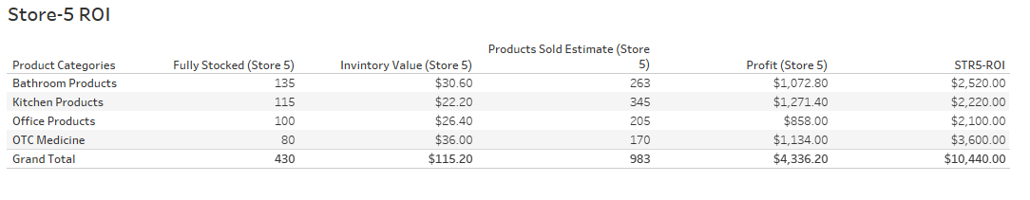
Store 6 Analysis:
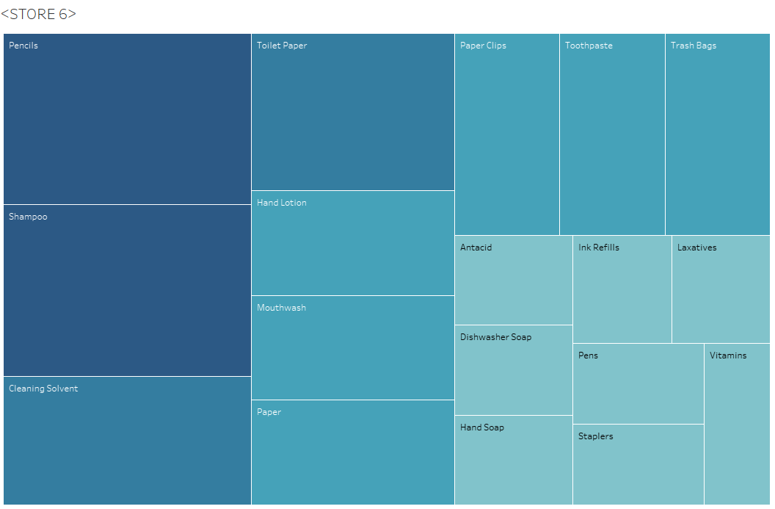
Store 6 Data Analysis:
Errors:
- In week 6 in Store 6 the hand soap product value is ether mis entered or wrong inventory control amounts were sent to Store 6. Without the time series data and detail of sold products or customer retention data this is undetermined
Store 6 Highest selling products:
Over the past 7 weeks to present these top products sold out the most and where not in stock
Product | Stock Amount | #Weeks Sold out | Product Avg (Needed Per Week) | Analysis
Scouring Pads | 20 | 4 | 4 | Increase Stock Amount and reorder point
Ink refills | 10 | 3 | 4 | Increase Stock Amount and reorder point
Dishwashing Soap | 15 | 3 | 4 | Increase Stock Amount and reorder point
Window Cleaner | 20 | 3 | 5 | Increase Stock Amount and reorder point
Shampoo | 20 | 3 | 7 | Increase Stock Amount and reorder point

I recommend increasing the stock amount to meet the demand especially for All products listed above that go more than 3 weeks without replenishing store 6 inventory. I recommend that the warehouse reorder point be dropped to a less amount to cover the demand of the listed products.
Recommendations Store 6:
- Increase sold out product reorder point by 5 units doubling the units being sent to 10 units per week on average.
- Work on new lean Inventory management strategy and 5s
Also, follow recommendations and best practices I have outlined in the recommendations section of the analysis above. The store should implement product placement and staging strategies to facilitate increasing profit margin through demand and visibility. I would also recommend instore management check to see if sound inventory management and tracking processes are being conducted correctly.
Product Average = Average of All sales divided by each week minus the full stock amount times 100 percent.
Store 6 Lowest selling products:
Product | Stock Amt | Sold (8weeks) | Product Avg (Needed Per Week) | Analysis
Pencils | 20 | 0 | 20 | Remove product from store or reduce stock Amount to 5 or increase resell point by 75%
Cleaning Solvent | 15 | 0 | 15 | Reduce Stock Amount to 10 and reorder point by 50%
Antacids | 15 | 0 | 9 | Reduce Stock Amount to 10 and reorder point by 50% Increased by 5 units
Paper | 20 | 0 | 9 | Reduce Stock Amount to 10 and reorder point by 50%

Store 6 Product Profit and Loss:
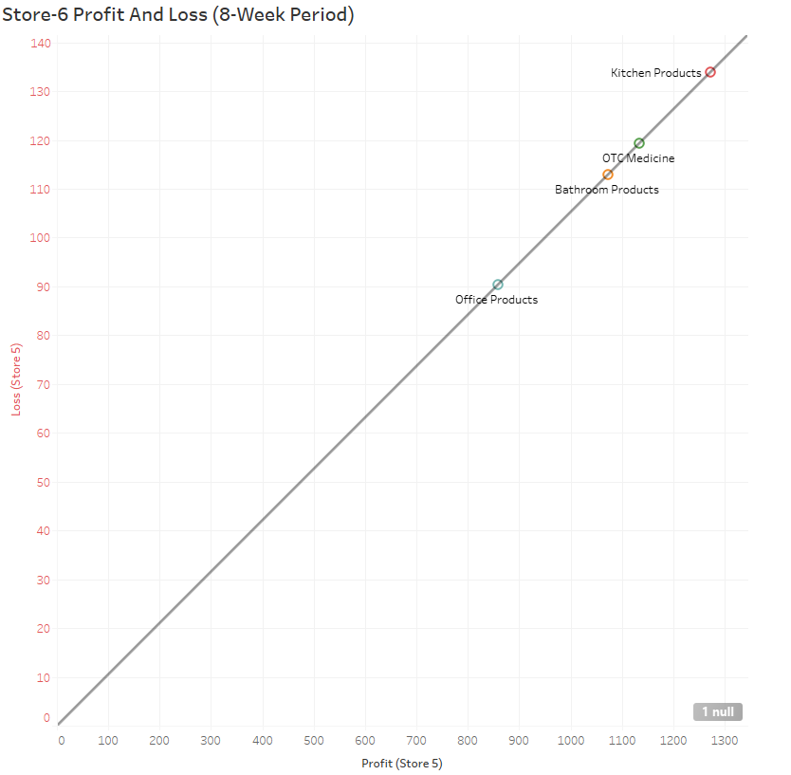
Store 6 Average Products Sold per Week
Here are the stores average percentages of sales per week.
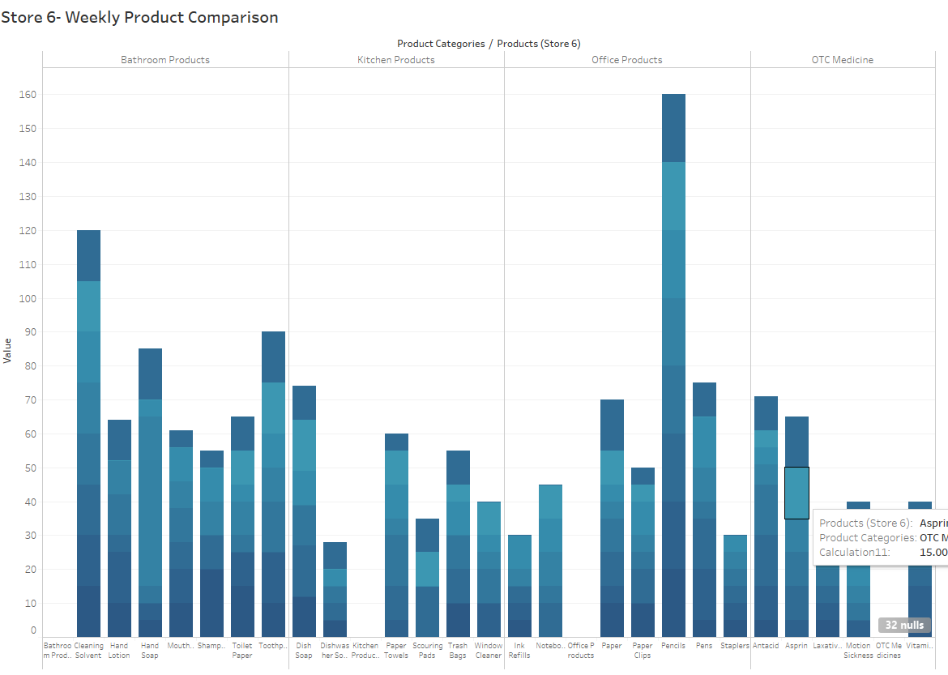
Store 6 Inventory Turn Over:
This is the measure of how often Super Shoppers Store 1 sells through its entire inventory in a set period of 8 weeks. By dividing the total sales by the average inventory value.
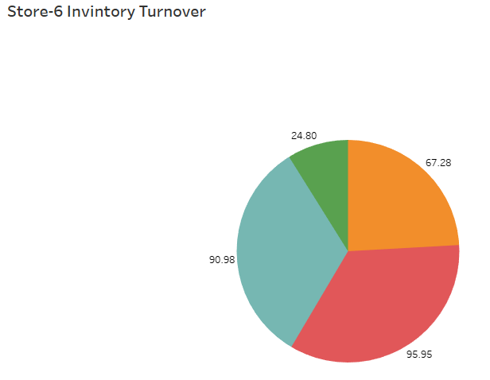
Store 6 Sell Through Rate:
Sell-through rate is a calculation that is used to measure the amount of product received from your manufacturer against the amount of product sold to your customers in a specified period of time.
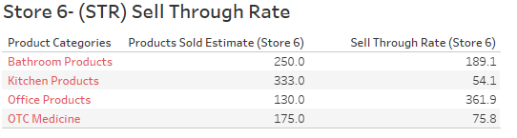
Store 6 ROI:
Return on investment based on calculating the profit made divided by the initial cost of products purchased in inventory on calculating the profit made divided by the initial cost of products purchased in inventory.
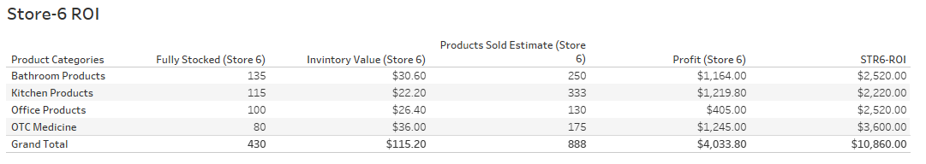
Store 7 Analysis:
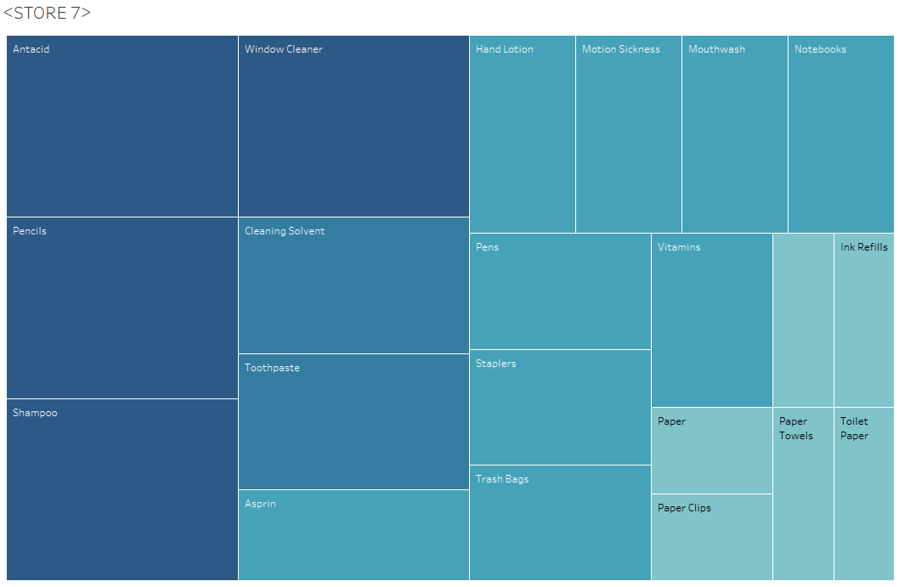
Store 7 Data Analysis:
Errors:
- From Week 3 to week 6 in Store 7 products sell out occurs because reorder point is to high and reorder amount to replenish products is too low.
Store 7 Highest selling products:
Over the past 7 weeks to present these top products sold out the most and where not in stock
Product | Stock Amount | #Weeks Sold out | Product Avg (Needed Per Week) | Analysis
Scouring Pads | 20 | 4 | 4
Dish Soap | 20 | 3 | 5 | Increase Stock Amount by 10 and reorder point add 5 units
Hand Soap | 20 | 3 | 4 | Increase Stock Amount by 10 and reorder point add 5 units
Dishwashing Soap | 15 | 3 | 5 | Increase Stock Amount by 10 and reorder point add 5 units
Toothpaste | 15 | 3 | 5 | Increase Stock Amount by 10 and reorder point add 5 units
Paper Clips | 10 | 3 | 8 | Increase Stock Amount by 10 and reorder point add 5 units
Laxatives | 10 | 3 | 5 | Increase Stock Amount by 10 and reorder point add 5 units

I recommend increasing the stock amount to meet the demand especially for All products listed above that go more than 3 weeks without replenishing store 5 inventory. I recommend that the warehouse reorder point be dropped to a less amount to cover the demand of the listed products.
Recommendations Store 7:
- Increase sold out product reorder point by 5 units doubling the units being sent to 10 units per week on average.
Also, follow recommendations and best practices I have outlined in the recommendations section of the analysis above.
Product Average = Average of All sales divided by each week minus the full stock amount times 100 percent.
Store 7 Lowest selling products:
Product | Stock Amt | Sold (8weeks) | Product Avg (Needed Per Week) | Analysis
Pencils | 20 | 0 | 20 | Remove product from store or reduce stock Amount to 5 or increase resell point by 75%
Cleaning Solvent | 15 | 0 | 15 | Reduce Stock Amount to 10 and reorder point by 50%

Store 7 Product Profit and Loss:
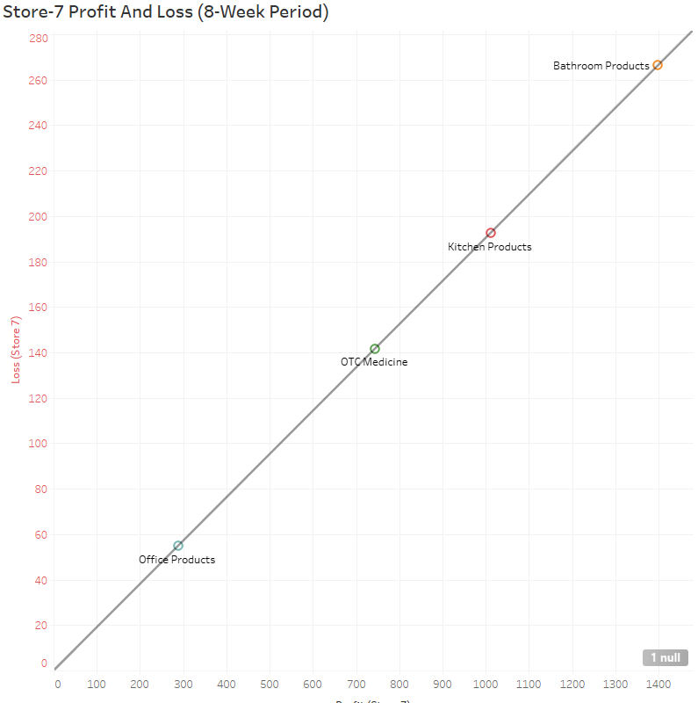
Store 7 Average Products Sold per Week
Here are the store average product percentages of sales per week.
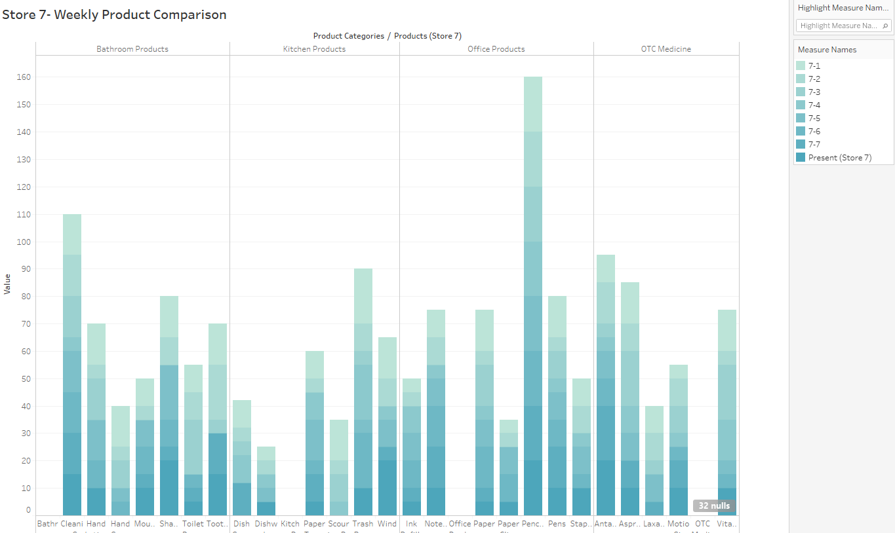
Store 7 Inventory Turn Over:
This is the measure of how often Super Shoppers Store 1 sells through its entire inventory in a set period of 8 weeks. By dividing the total sales by the average inventory value.
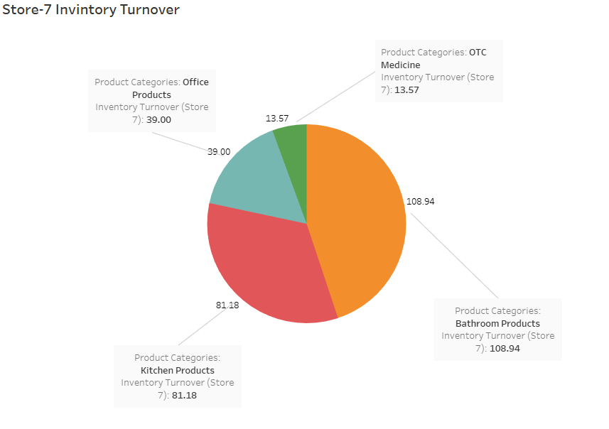
Store 7 Sell Through Rate:
Sell-through rate is a calculation that is used to measure the amount of product received from your manufacturer against the amount of product sold to your customers in a specified period of time.
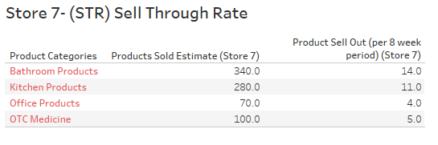
Store 7 ROI:
Return on investment based on calculating the profit made divided by the initial cost of products purchased in inventory.
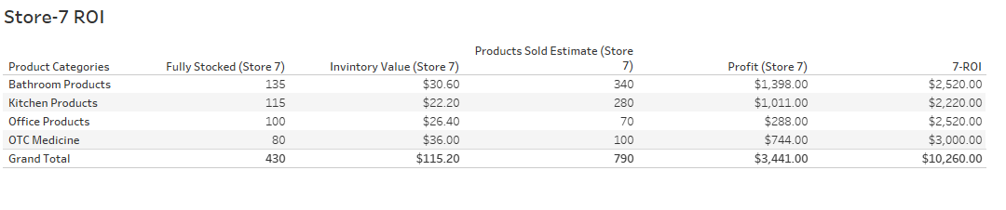
Store 8 Analysis:
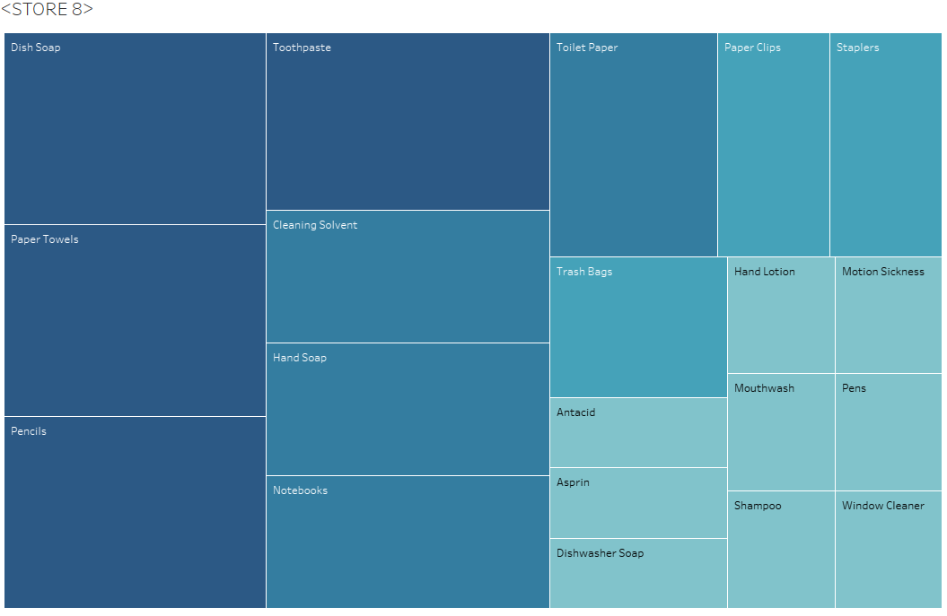
Store 8 Data Analysis:
Errors:
- In week 3 in Store 8 products seem to being doing well until this point. After week 3 multiple incursions of no inventory has been delivered for the items listed below
- Patter with scouring pads and Ink refills is persisting. This suggest that there is a point of sale error, warehouse reorder error, or inventory management error.
Store 8 Highest selling products:
Over the past 8 weeks to present these top products sold out the most and where not in stock
Product | Stock Amount | #Weeks Sold out | Product Avg (Needed Per Week) | Analysis
Scouring Pads | 20 | 5 | 4 | Increase Stock Amount by 10 and reorder point add 5 units.
Ink refills | 10 | 4 | 6 | Increase Stock Amount by 10 and reorder point add 5 units.
Shampoo | 20 | 4 | 4 | Increase Stock Amount by 10 and reorder point add 5 units.
Laxatives | 10 | 3 | 5 | Increase Stock Amount by 10 and reorder point add 5 units.

I recommend increasing the stock amount to meet the demand especially for All products listed above that go more than 3-4 weeks without replenishing store 8 inventory. I recommend that the warehouse reorder point be dropped to a less amount to cover the demand of the listed products. Also, follow recommendations and best practices I have outlined in the recommendations section of the analysis.
Product Average = Average of All sales divided by each week minus the full stock amount times 100 percent.
Store 8 Lowest selling products:
Product | Stock Amt | Sold (8weeks) | Product Avg (Needed Per Week) | Analysis
Pencils | 20 | 0 | 20 | Remove product from store or reduce stock Amount to 5 or increase resell point by 75%
Cleaning Solvent | 15 | 0 | 15 | Reduce Stock Amount to 10 and reorder point by 50%

Store 8 Product Profit and Loss:
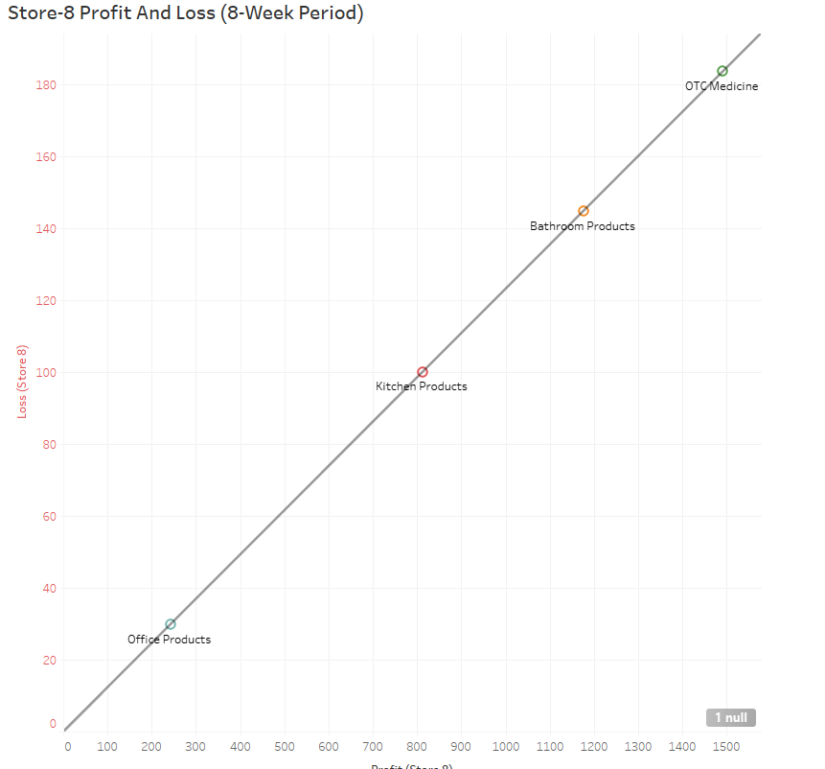
Store 8 Average Products Sold per Week
Here are the stores average percentages of sales per week.
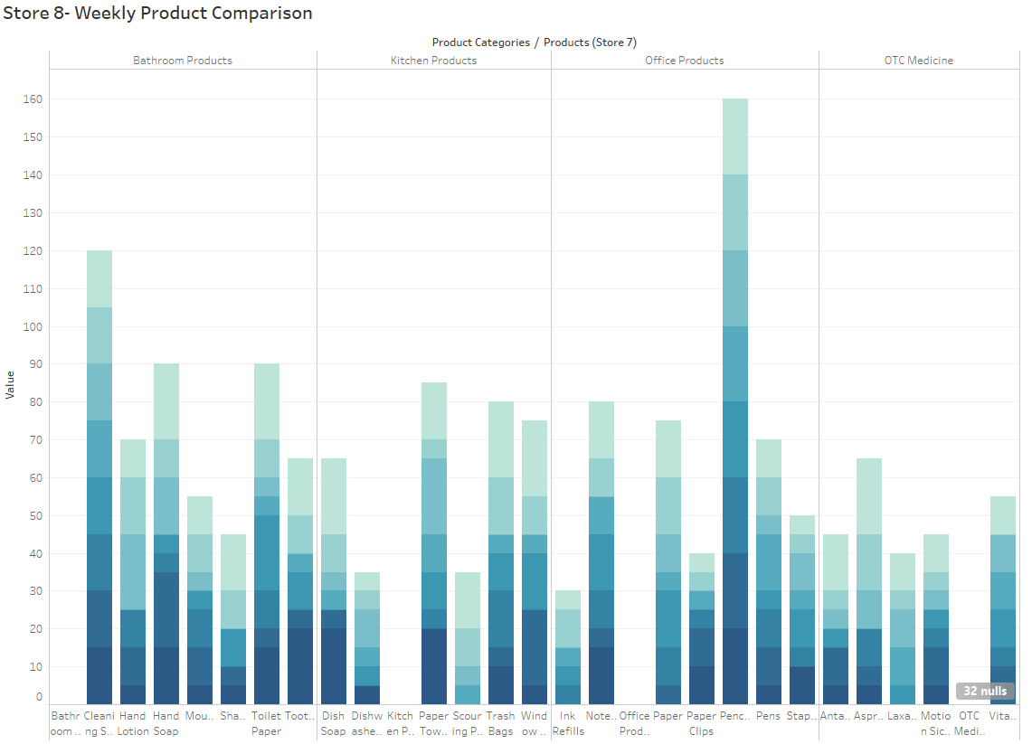
Store 8 Inventory Turn Over:
This is the measure of how often Super Shoppers Store 1 sells through its entire inventory in a set period of 8 weeks. By dividing the total sales by the average inventory value.
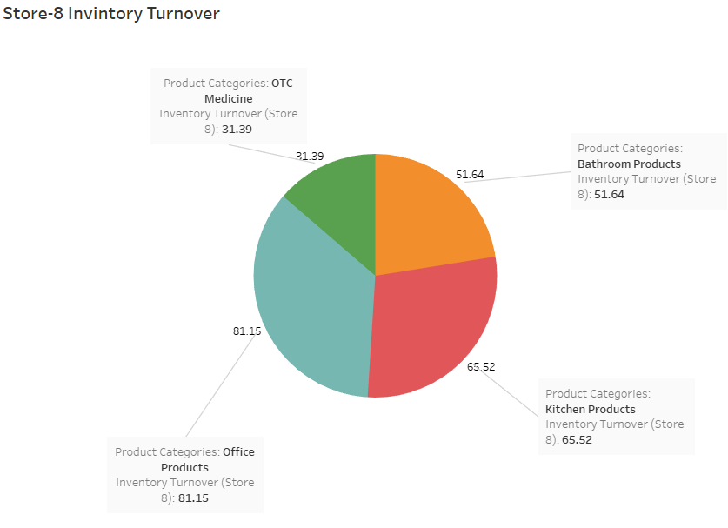
Store 8 Sell Through Rate:
Sell-through rate is a calculation that is used to measure the amount of product received from your manufacturer against the amount of product sold to your customers in a specified period of time.
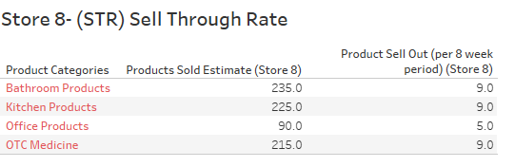
Store 8 ROI:
Return on investment based on calculating the profit made divided by the initial cost of products purchased in inventory.
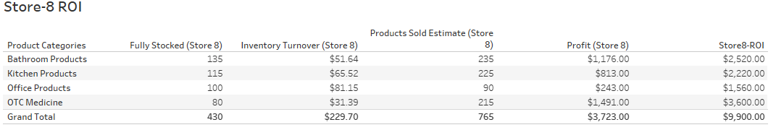
Store 9 Analysis:
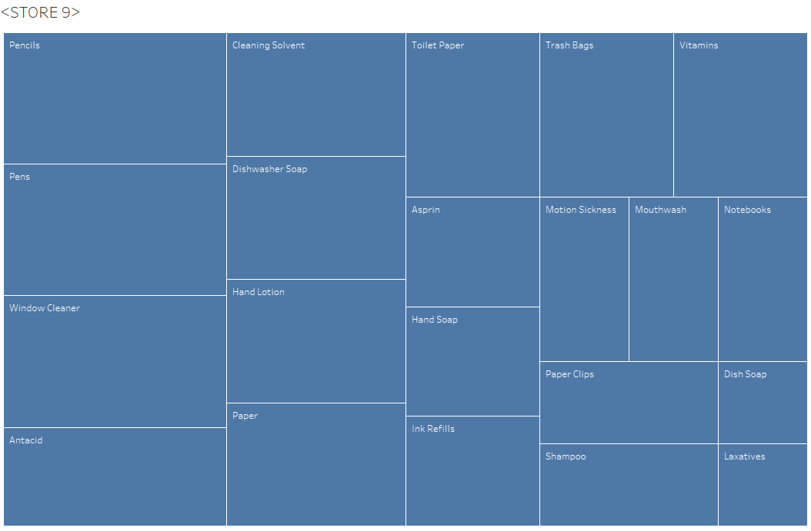
Store 9 Data Analysis:
Errors:
- Scouring Pads being out of stock for more than 4 weeks
- Pencils and Cleaning solvent not sold in 8-weeks
Store 9 Highest Selling products:
Over the past 7 weeks to present these top products sold out the most and where not in stock
Product | Stock Amount | #Weeks Sold out | Product Avg (Needed Per Week) | Analysis
Scouring Pads | 20 | 5 | 4 | Increase Stock Amount by 10 and reorder point add 5 units.
Ink refills | 10 | 4 | 4 | Increase Stock Amount by 10 and reorder point add 5 units.
Hand Soap | 20 | 4 | 4 | Increase Stock Amount by 10 and reorder point add 5 units.
Aspirin | 20 | 3 | 7 | Increase Stock Amount by 10 and reorder point add 5 units.
Dishwashing Soap | 15 | 4 | 5 | Increase Stock Amount by 10 and reorder point add 5 units.
Motion Sickness | 10 | 3 | 4 | Increase Stock Amount by 10 and reorder point add 5 units.

I recommend increasing the stock amount to meet the demand especially for All products listed above that go more than 3 weeks without replenishing store 9 inventory. I recommend that the warehouse reorder point be dropped to a less amount to cover the demand of the listed products.
Recommendations Store 9:
- Implement proper training and inventory management collaboration with warehouse
Also, follow recommendations and best practices I have outlined in the recommendations section of the analysis above.
Product Average = Average of All sales divided by each week minus the full stock amount times 100 percent.
Store 9 Lowest selling products:
Product | Stock Amt | Sold (8weeks) | Product Avg (Needed Per Week) | Analysis
Pencils | 20 | 0 | 20 | Remove product from store or reduce stock Amount to 5 or increase resell point by 75%
Cleaning Solvent | 15 | 0 | 15 | Reduce Stock Amount to 10 and reorder point by 50%

Store 9 Product Profit and Loss:
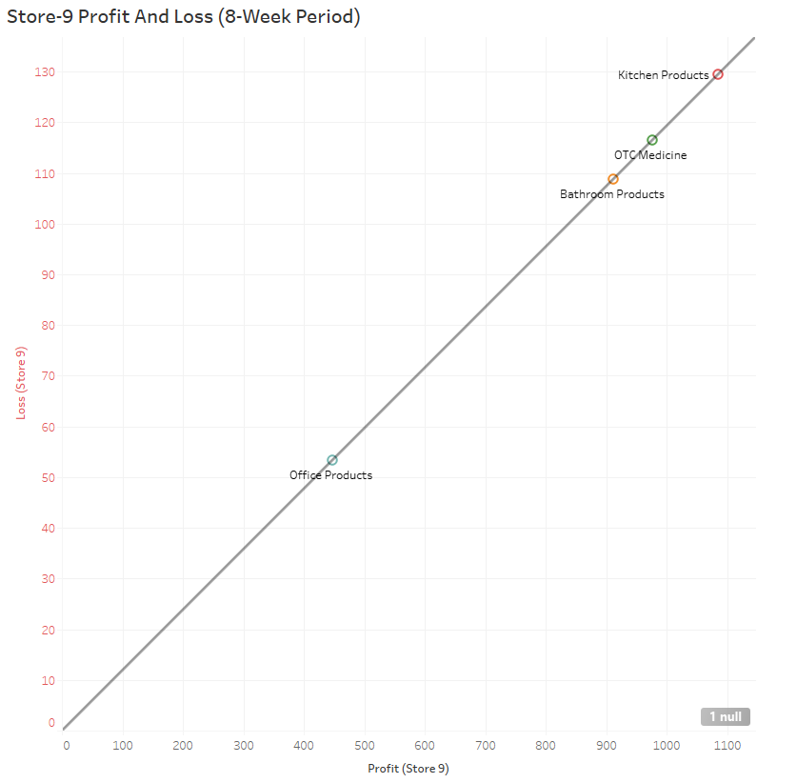
Store 9 Average Products Sold per Week
Here are the stores average percentages of sales per week
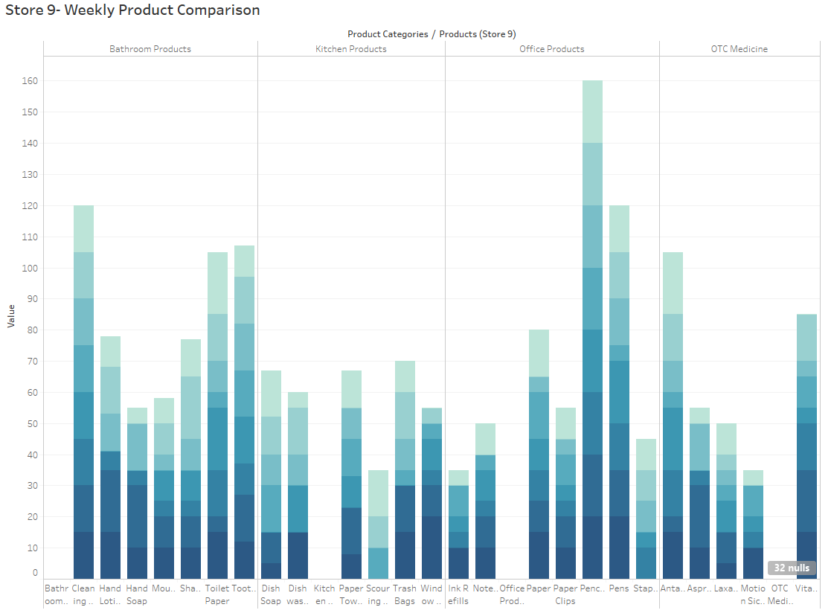
Store 9 Inventory Turn Over:
This is the measure of how often Super Shoppers Store 1 sells through its entire inventory in a set period of 8 weeks. By dividing the total sales by the average inventory value.
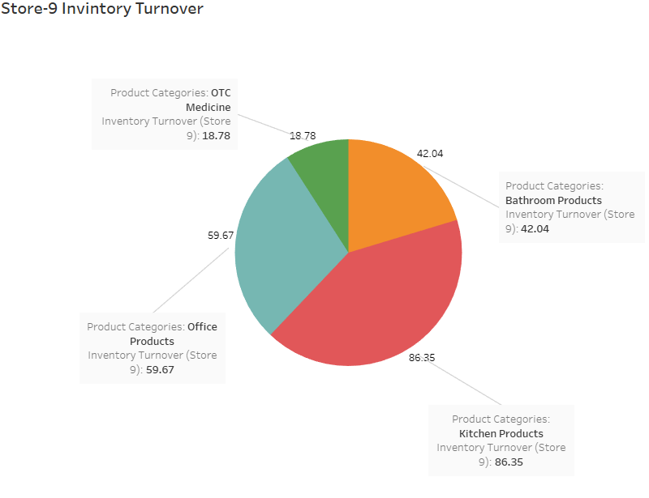
Store 9 Sell Through Rate:
Sell-through rate is a calculation that is used to measure the amount of product received from your manufacturer against the amount of product sold to your customers in a specified period of time.
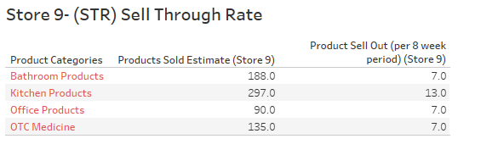
Store 9 ROI:
Return on investment based on calculating the profit made divided by the initial cost of products purchased in inventory.
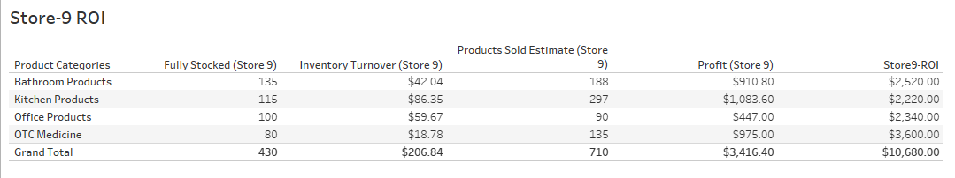
Store 10 Analysis:
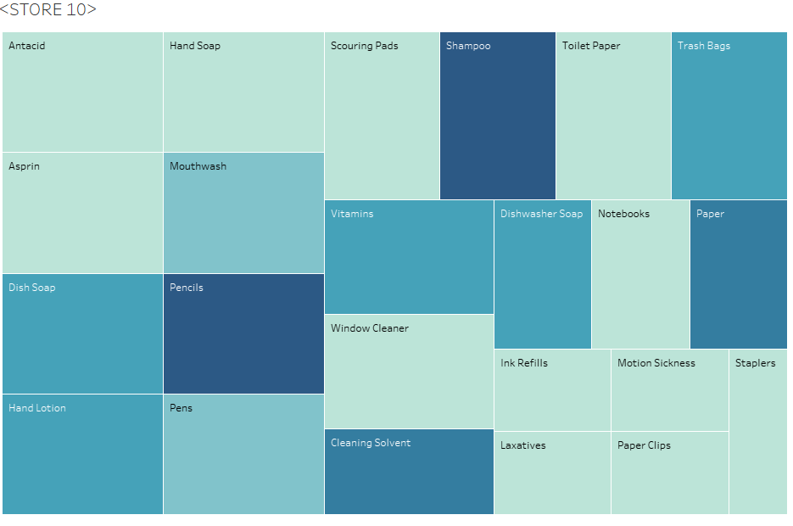
Store 10 Data Analysis:
Errors:
- By far the worst store of them all as far as Inventory management and reorder points are concerned. Over 11 products that go unstocked/ out of stock for 3 to 5 weeks.
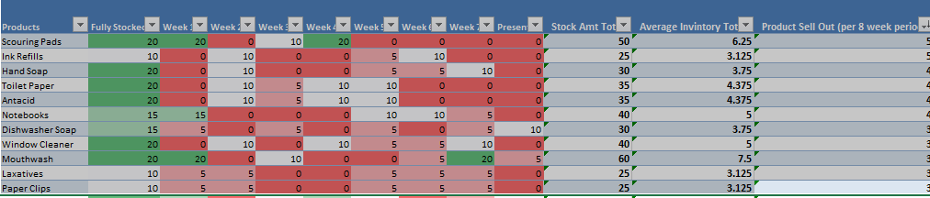
Store 10 Highest selling products:
Over the past 7 weeks to present these top products sold out the most and where not in stock
Product | Stock Amount | #Weeks Sold out | Product Avg (Needed Per Week) | Analysis
Scouring Pads | 20 | 5 | 6 | Increase Stock Amount by 10 and reorder point add 5 units.
Ink refills | 10 | 5 | 3 | Increase Stock Amount by 10 and reorder point add 5 units.
Hand Soap | 20 | 4 | 4 | Increase Stock Amount by 10 and reorder point add 5 units.
Toilet Paper | 10 | 4 | 4 | Increase Stock Amount by 10 and reorder point add 5 units.
Antacids |  | 4 | 4 | Increase Stock Amount by 10 and reorder point add 5 units.
Notebooks | 15 | 4 | 5 | Increase Stock Amount by 10 and reorder point add 5 units.
Dishwashing Soap | 15 | 4 | 3 | Increase Stock Amount by 10 and reorder point add 5 units.
Window Cleaner |  | 3 | 5 | Increase Stock Amount by 10 and reorder point add 5 units.
Mouthwash |  | 3 | 7 | Increase Stock Amount by 10 and reorder point add 5 units.
Laxatives | 10 | 3 | 3 | Increase Stock Amount by 10 and reorder point add 5 units.
Paperclips |  | 3 | 3 | Increase Stock Amount by 10 and reorder point add 5 units.

I recommend increasing the stock amount to meet the demand especially for All products listed above that go more than 3 weeks without replenishing store 5 inventory. I recommend that the warehouse reorder point be dropped to a less amount to cover the demand of the listed products.
Recommendations Store 10:
- Increase sold out product reorder point by 5 units doubling the units being sent to 10 units per week on average.
- Employee training
- Implement new SAM Lean management system for inventory
- Implement and train warehouse and store 10 on implementing the 5 S’s
- Implement sound inventory management scheduling

Also, follow recommendations and best practices I have outlined in the recommendations section of the analysis above. The store should implement product placement and staging strategies to facilitate increasing profit margin through demand and visibility. I would also recommend instore management check to see if sound inventory management and tracking processes are being conducted correctly.
Product Average = Average of All sales divided by each week minus the full stock amount times 100 percent.
Store 10 Lowest selling products:
Product | Stock Amt | Sold (8weeks) | Product Avg (Needed Per Week) | Analysis
Pencils | 20 | 0 | 20 | Remove product from store or reduce stock Amount to 5 or increase resell point by 75%
Cleaning Solvent | 15 | 0 | 15 | Reduce Stock Amount to 10 and reorder point by 50%

Store 10 Product Profit and Loss:
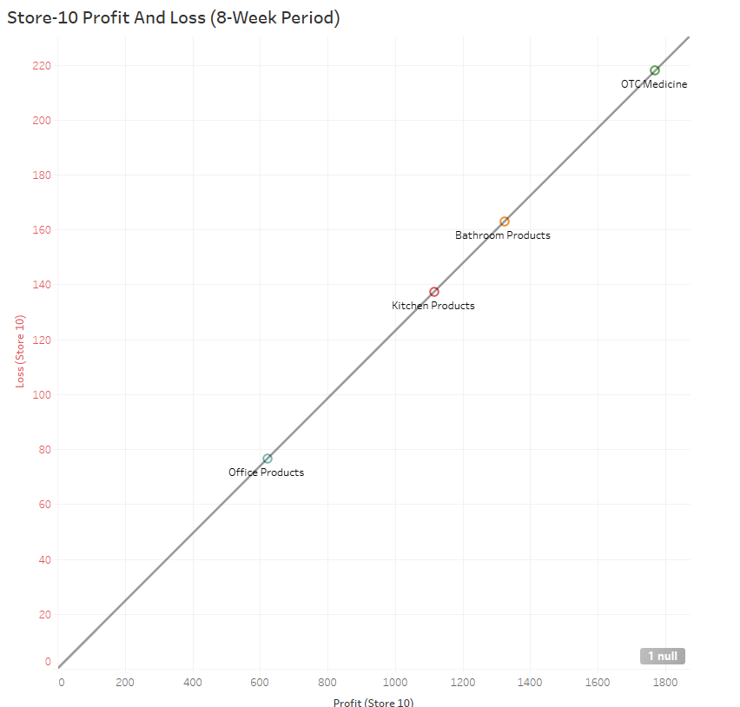
Store 10 Average Products Sold per Week
Here are the stores average percentages of sales per week.
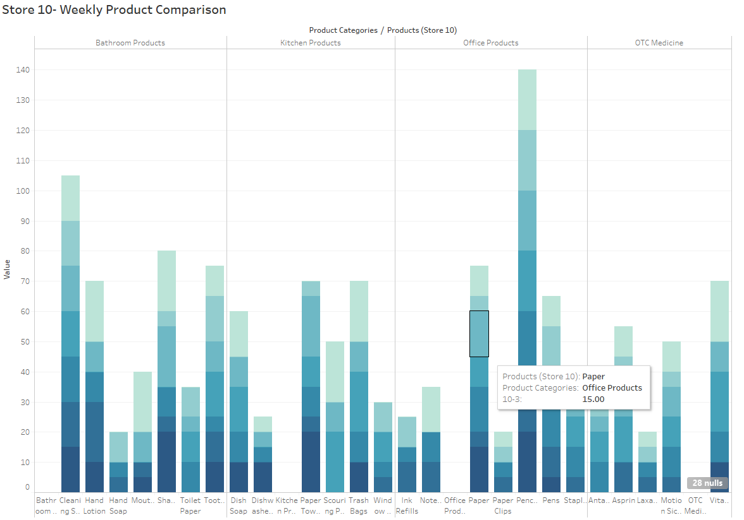
Store 10 Inventory Turn Over:
This is the measure of how often Super Shoppers Store 1 sells through its entire inventory in a set period of 8 weeks. By dividing the total sales by the average inventory value.
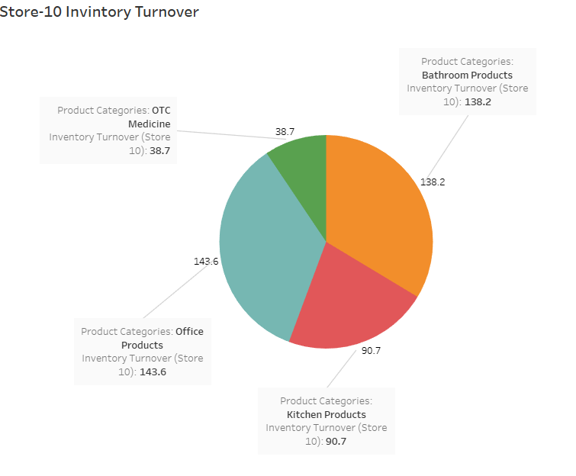
Store 10 Sell Through Rate:
Sell-through rate is a calculation that is used to measure the amount of product received from your manufacturer against the amount of product sold to your customers in a specified period of time.
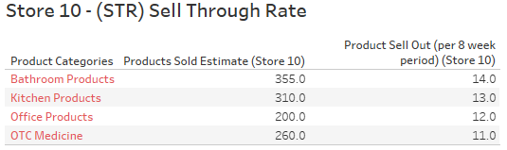
Store 10 ROI:
Return on investment based on calculating the profit made divided by the initial cost of products purchased in inventory.
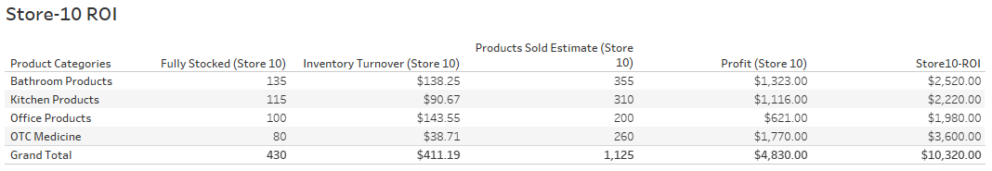
This concludes my in-depth analysis of each of the 10-Super Shopper Store locations. Please see the recommendations and the analysis at the beginning of the document. My next report be a full Analysis and presentation incorporating the data and overall factors and recommendations. Also, it will contain the inclusive metrics and combinatorics data analysis such as ( regression analysis, ROI, Inventory, Turn Over, Sell Through, Averages Inventory sales) Overall factors for the entire Super Shopper Company.
Course Project - Accounting Case Study
This analysis is broken down into categories based off the Super Shoppers outlet criteria of 10 Stores, 1 warehousing unit, and accounting department. The combined data will be used to answer specific business questions to provide insights.
Accounting Case Study Section Index:
- Insights to identify
- Business Questions
- Critical Issues
- Accounting Analysis
- Recommendations
Supper Shoppers Store sales analysis report will seek to answer several business questions in relation to accounting, inventory, and warehouse management, infrastructure, optimization, and best practices.
Insights to identify:
- Efficient Accounting Practices?
- Ineffective Processes and systems
- Identifying Inventory Management flaws
- Reducing cost and overhead with overstocked inventory
- Effective product pricing and markup
- Inventory Patterns
- Keeping the shelves stocked and best-selling products on hand
- Effective Products margins
Business Questions:
In order to establish sound metrics understanding the dataset, revealing specific metrics and key indicators to answering the following questions.
- How frequently should the inventory status for an item be reviewed?
- When should a replenishment order be placed?
- What should be the order size?
- How to gain higher profit margins?
- Which products are running out of stock first per store
- What is the frequency of OOS (Out of Stock)?
- How to avoid OOS Stockouts
- Which products are not selling?
- What is inventory cost? CI
- What system (POF) Points of Failure exist?
- Is Supper shoppers accounting using the correct (ICS) Inventory Control System?
- Is the Point of Sale (POS) system being used good?
- Is there effective Inventory Control Systems in place?
- What is procurement lead time?
To best answer these questions I have implemented a data workflow to facilitate new metrics based on calculations involving the data combined for all 10 Super Shopper Stores and included department to provide insights on, Inventory Carrying cost, Shortage Cost, Inventory Turnover, (RIO) Return On Investment, Sell-Through-Rate, Sales Velocity, Margins Per Product Unit, Sale Price With Margin Cost, Average Sales, Per Week, Per Store, Per Product, Average Inventory Values, Individual Store Profit & Loss Regressions data from all 10 stores.
Accounting Use Case Diagram:
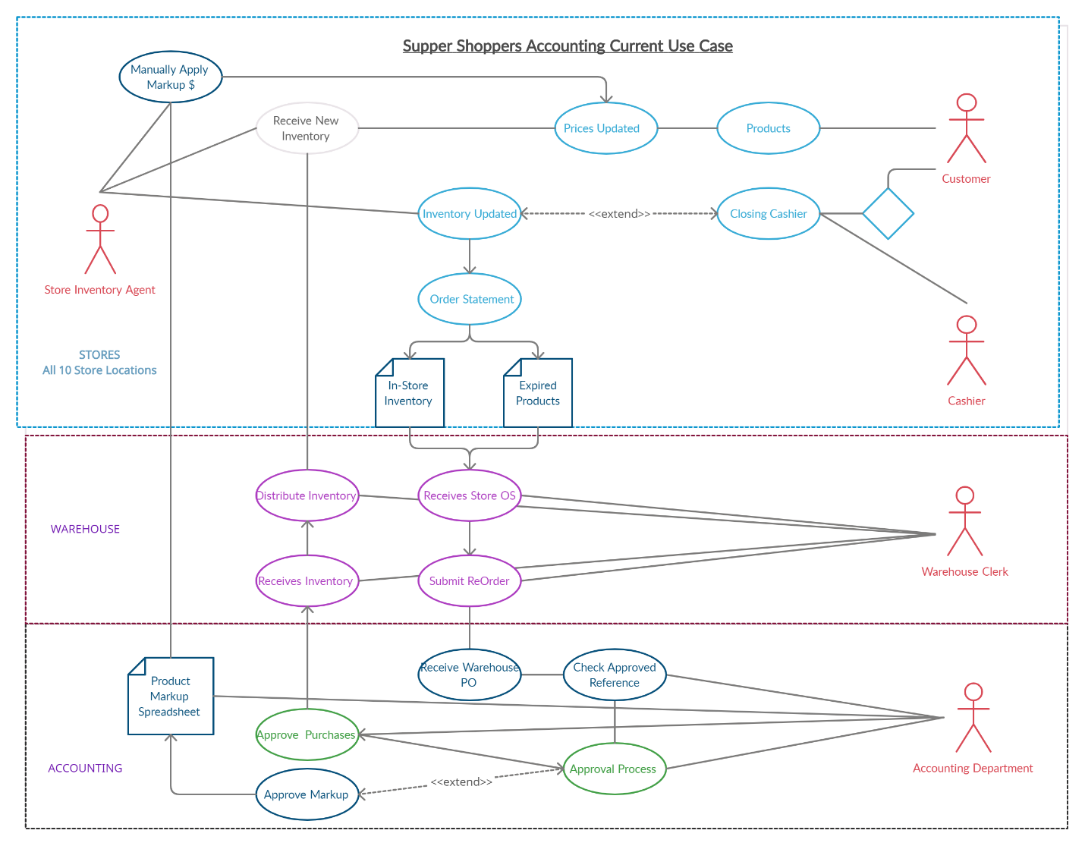
Critical Issues:
- Accounting approval process implements limitations and allotted time constraints that allow stock levels to fall, causing Stockouts in all stores due to longer procurement lead times and ineffective management systems.
- Longer lead time plus the lower reorder point stock procurement and the lower single point orders which are on average 5-10 products per order, per product, per store are to low. essentially conflicting with the order up to level (T,S) system currently in place.
- The inventory management of the company is followed and maintained at a 99% fill rate. Which needs to reevaluate (SS) Safety Stock levels of inventory needed to meet the fluctuations in demand.
- The company’s is currently using has a decentralized POS system. Each store which requires manual weekly warehouse record updates results as a point of failure due to human errors and possible miscalculations.
- The warehouse managers were asked to check the inventory manually. This presents another time constraint issue, when time required to track it down and the costs of the warehouse.
- warehouse managers are asked to manually update pricing on product through a spread sheet provided by accounting. This also causes time constraint issues on both ends.
- Warehouse has to manually enter price increase and margin data through a spreadsheet distributed to all the stores which is determined upon approval by accounting and presumably specific for each individual store location. None of the other departments know when they are getting this spreadsheet or if it will facilitate changes that are necessary in time given the current inventory in stock or the inventory needed.
- Not Implement Competitive Pricing and Price Matching Offers When a company is unable to anticipate competitor price changes or is not equipped to make corresponding changes in a timely fashion, a retailer may offer to match advertised competitor prices. This allows the retailer to maintain a competitive price point for those who become aware of the competitor's offer without having to officially change the price within the retailer’s point of sale system.
Accounting Analysis:
An Average Procurement lead time is 14 days (or 2 weeks) Supers hoppers Store seems to have a 2-4-week Procurement lead time on average.
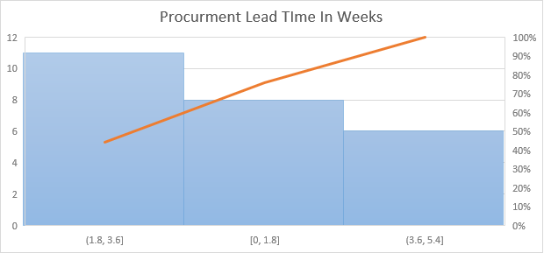
Profit totals:
For each store I counted the amount of stock missing, stockouts, and calculated the margins for each individual product and then multiplied that amount by the number of products sold for 8-week period of time. The total profit for all stores combine was $4633.00 in total
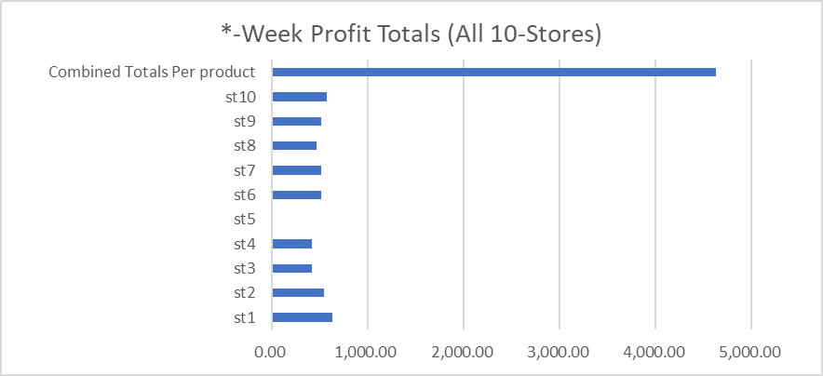
Stockouts:
I calculated stockouts for each individual store to get running totals. By calculating the amount of time (weeks) inventory was zeroed out and consecutive. This will show in weeks how often products where no longer in stock awaiting on inventory.
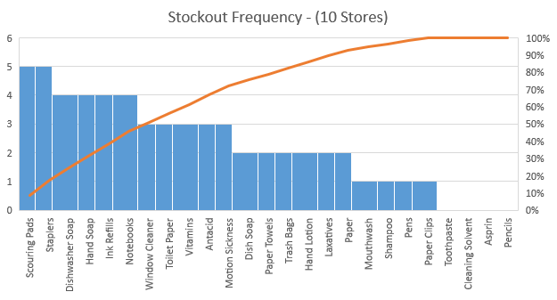
The data shows that 467 times, over the past 8 weeks across all 10 stores total where out of stock or had no inventory for that week less than or greater than 5 units on hand.
The data shows that the overall margin percentage for each product over 8-week period of time is consistent of only 20% per product. This is a bad practice due to sale rate of individual products is not being taken into consideration. For example, lowering product pricing and offering discounts on best selling items have show to sell more products on average increasing the profit margin up to 30-60%. Whereas increasing this profit margin on products that do not sell can help recover loss from sales, stock, inventory expiration, and other factors.
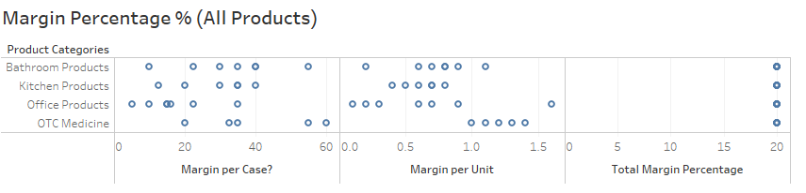
Applied 20% Margin per 50 units:
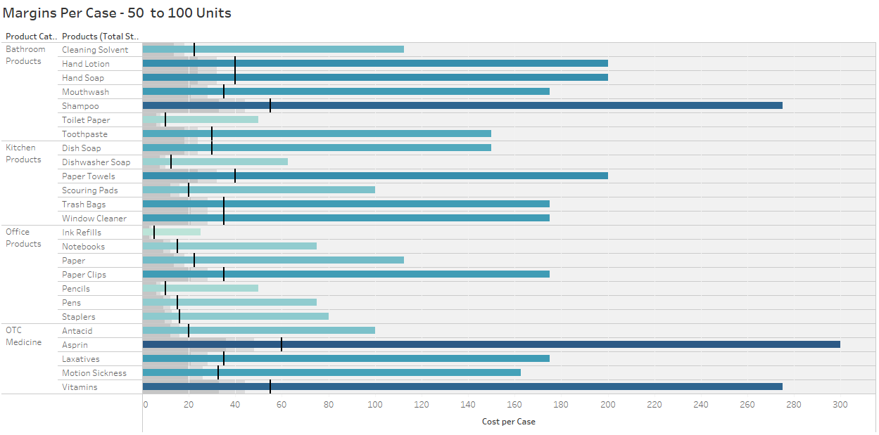
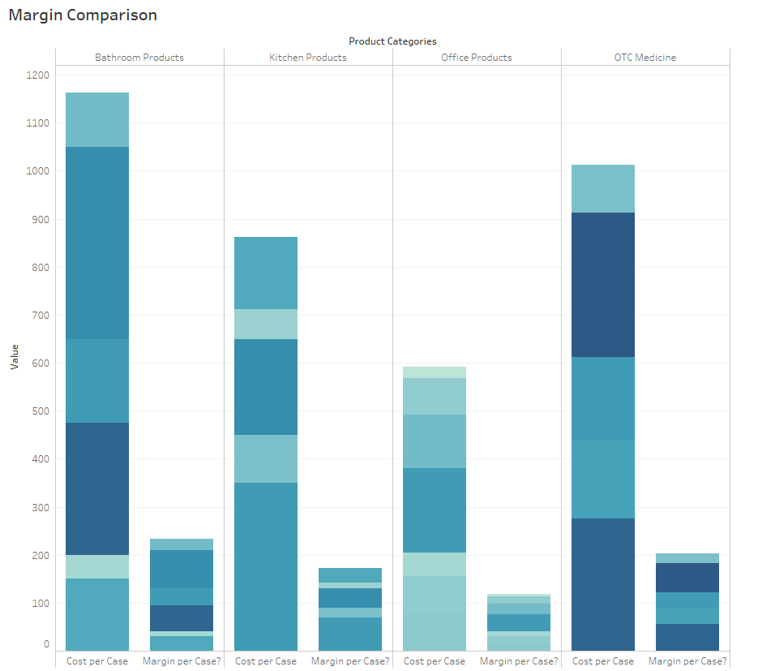
Sell-through rate is a calculation that is used to measure the amount of product received from Super Shoppers manufacturer against the amount of product sold to your customers in a specified period of time. To calculate it, using the total sales and divide that number by the stock on hand. Multiply this number by 100 to convert it to a percentage. This is an estimate not an exact figure based on the estimated values sold by each store with 95% confidence. This shows us how our demand for sales is not being met due to lack of inventory.
STR -Conclusion: the data supports the hypothesis that Increasing inventory and lowering reorder point to stock items faster could meet the demand and increase overall profit in all stores.
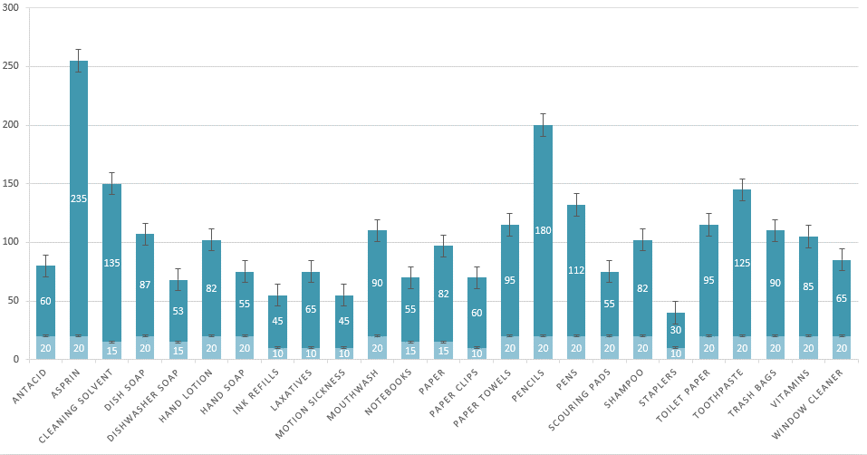
Number of Stockouts (OOS) Per Store: Counting the amount of times stock was at 0 per week per store for 8-week period of time averaged 2-month period by 365 days in a year.
Cycle Service Level is a calculation used to determine the proper safety stock levels. Safety stock levels. With the analysis we can see if the warehouse is stocking enough or too much of a product which results in profit loss. Safety stock (SS) is an additional amount of inventory that is carried to meet fluctuations in demand. Safety stock helps reduce the probability of stockout
Recommended Accounting Metrics Needed:
These are additional recommended metrics Supper Shoppers company should consider. More data is needed to make accurate full analysis.
- Sales velocity is a way to measure how fast Super Shoppers products sell when they are available to thier customers.
- Inventory Turnover is a measure of how often a business sells through its entire inventory in a set period of time (often a year).
- Carrying Cost percentage is important for calculating the profit you’re making on your inventory.
- Capital Cost is the largest component of carrying cost incurred by businesses.
- Inventory Service Cost includes IT hardware, applications, tax, and insurance.
- Inventory Risk Costs include the shrinkage of inventory (which refers to the loss of products because of factors other than sale), theft, and administrative errors (such as misplaced goods, errors in shipping, or late system updates).
- Storage Space Cost includes the rent paid to warehouse your products, air conditioning and heating, lighting, transportation, and other costs associated with the physical warehouse.
- Return on investment (ROI) is a ratio used to determine a business’s profitability.
Recommendations:
Based on the current analysis, I feel these recommendations listed below are in good order to facilitate proper inventory managements, systems process, and best practices. That will be effective to regain lost time, being more profitable, and more dynamic .
- Centralizing the Warehousing & Server capabilities: The company can start a new a centralized warehouse and network infrastructure to remove independent server which all act as a point of failure when they are distributed. Implement this solution near the manufacturing site at the main warehouse to serve purchase and customer orders (Mittal, 2020).
- Implementing multiple warehouses from east to west or north to south allowing supper Shoppers company the ability to pull orders in a distributed manner separately adjusting the supply chain of products to all its demand.
- Offer Competitive Pricing and Price Matching Offers The data shows that base rate and single inventory amounts are only shipped to store at rates of 5-10 products per cycle. Increasing the stock amount and decreasing reorder points would allot for maximum feasibility (Mittal, 2020).
- ABC Analytics Minimum and Maximum Levels with Reorder Features such as auto Ordering and Order Cycles, top and Bottom Seller Identification, cloud Inventory Management.
- Verify all receivables with packing slips and Purchase Orders through digital cloud-based technology as a payment basis for the account’s payable office. Also, coordinate a daily campus and off campus distribution system.
- Training staff to use the technology and inventory management techniques. Such as lean process, scheduled meetings, establishing KPI’s Categorize Your Inventory Using ABC Analysis hierarchy, Implement Reorder Point Formulas, Just-in-time system, or Kanban system (DEAR Systems, 2017), (Systems, 2017)
- Create efficient Stock Order Cycles and Automatic Ordering -A great point of sale solution can also create recurring order cycles for each individual product. Again, these can be manually updated, but the software identifies the ordering pattern and automatically requests the new order according to the cycle. Once implemented, it is completed entirely by your POS.
- Real-Time Inventory Management - Implement a cloud-based POS solution, all inventory updates are made immediately upon an order, delivery, sale, or return. This ensures that inventory count is accurate, and never out of stock. This will also help to facilitate the accrued time loss from stores having to wait on a spreadsheet from accounting assuming the rigorous accounting approval process (Naddor, 1966).
- Training staff to use the technology and inventory management tools. Such as (SAM) Software Asset Management Software (Gartner Peer Insights, 2020).
- Implement vendor outsourcing would also be a feasible option due to the following: parameters:
  - Lower Inventory Cost.
  - Less Warehousing operation expenses.
  - Managed inventory is the most important task.
  - Optimize the fill rate at lower cost.
- item is Implement Continuous Review, Fixed Order Quantity (s, Q) System implements inventory position of an item is monitored continuously and is known at all times. Inventory position of an defined as the number of items held currently in stock plus the number of items on order (Mittal, 2020). As demand arises, items are withdrawn from inventory. Simultaneously, the inventory position is updated. This process continues until the inventory level reaches a predetermined level, s, referred to as the reorder point. At this point, anew replenishment order of size Q is placed, which is filled after time L, referred to as the lead time. Receipt of the order increases the inventory position. The process of order-point, order-quantity system as depicted below (Chopra, 2010).
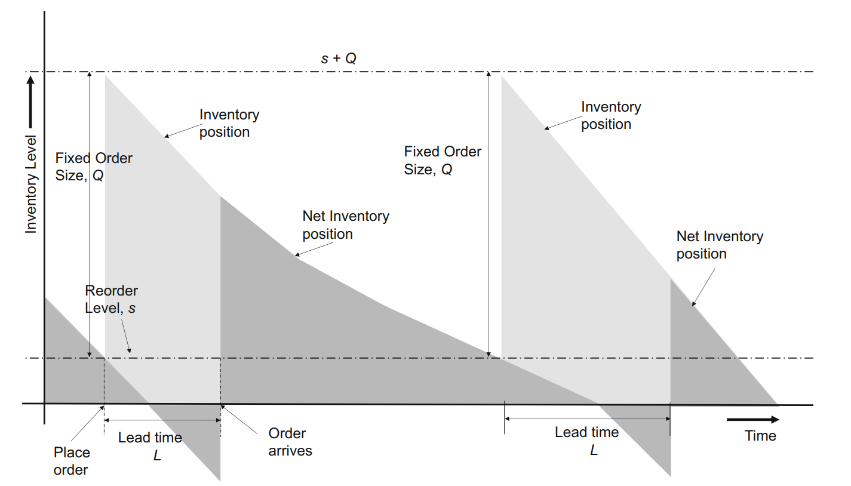
- Implement the following inventory management and control system models on the frequency basis of EOQs, CI, Fill rate and other suggested metrics for single and multiple inventory items such as:
  - Instantaneous Supply Model (ISM)
  - Dynamic Inventory Control
  - Stochastic Inventory Models
  - Multi- Inventory Models
  - Selective Inventory Models

Course Project - Transferable Reflection
This is assignment challenged me to implement a full data analysis project from start to finish. I was able to learn fundamental applicable skills based on the expectations of this project decision-maker and numerous business questions. that leads me to compute specific data to allocate actionable insights. This was in fact of the hardest projects I have had to do, but I believe all the skills I learned through trial and error are transferable in the real world.
From taking the data set, breaking it down, by specific categories, departments, existing metrics, non-existing metrics, running scripts, multiple tools(Python, Excel, Tableau, and SAS) to derive computations and calculations that answer specific business questions, transform raw data into applicable information, building out specific analysis the quantitative measures categorical independent variables, combining independent analysis, compiling the analysis into a simplified final presentation that revealed real insights and visualizations to communicate findings and issues, and diving into research on Inventory management practices trying to understand the industry to find solutions for problems while running the appropriate types directions systems and control processes from that research.
I was able to utilize my abilities to create visual communication elements to simplify and express my findings into actionable insights, business logic, and business intelligence. That not only answered the preliminary area questions being asked by the mock-up for Shoppers grocery chain but other questions that facilitate causation for many of the issues which led me to find many different metrics. Imagine the world I'll be working with teams I'm felt this was awesome practice into a potential real-world scenario.

I plan on incorporating the skills that I have learned through this Capstone project and if specific goals that I am trying to ascertain both professionally and personally. For the past 15 years, I've been a software programmer, recently studying to become a data scientist and earn a master's in data science.
My focus is to solve problems that haven't been solved to come up with solutions that can only be seen through the acquisition of data and Technology such as statistics, artificial intelligence, machine learning, deep learning, and reinforcement learning. I plan to use the skills that I have acquired to join teams of data scientists working on real world problems gain experience in the field of facilitating real-world solutions.
I pride myself on being a determined problem solver, being able to see the different angles of a certain situation or problem that most other people cannot see. Essentially, I advance my intuition to drive my acquired skills and mindset from military service, school, and life to push through and persevere through situation or solve problems through dedication. While utilizing these advanced tools and techniques I have learned to reach my goals.
My personal objectives after gaining experience is to get involved with the GSA government contracting or implementing my private startup. Only after I have acquired experience working with teams of professionals in this field. For instance, I have an invention / application I have been developing for past 3 years which utilizes technologies, analytics, and hardware that incorporate machine learning capabilities and has the potential to save people's lives. I want to incorporate this knowledge into real factors that will allow me to successfully become part of a team and grow to become a successful data scientist. Real success is determined by the measure of experience on has. One cannot gain experience unless they utilize trait skills of those around them who aspire to solve the problems and persevere. This is a personal philosophy I live by that Nothing can stop the man/women with the right mental attitude from achieving their goals.

References
(n.d.). Retrieved from https://www.accountingtools.com: https://www.accountingtools.com/articles/accounting-department-responsibilities.html
5S Today. (2020). What is 5S? Retrieved from https://www.5stoday.com: https://www.5stoday.com/what-is-5s/
Accounting Tools. (2020, Dec 11). Accounting department responsibilities. Retrieved from https://www.accountingtools.com: https://www.accountingtools.com/articles/accounting-department-responsibilities.html
Chopra, S. &. (2010). Supply chain management – strategy, planning and operation. New Jersey: Pearson Education, Inc.
Chron. (2020). Retail Workflow & Operational Processes. Retrieved from https://smallbusiness.chron.com: https://smallbusiness.chron.com/retail-workflow-operational-processes-15385.html
DEAR Systems. (2017, Aug 05). What is a Reorder Point Formula and How is it Calculated? Retrieved from https://dearsystems.com: https://dearsystems.com/reorder-point-formula/
Fdm4. (2020, Nov 25). HOW TO ORGANIZE WAREHOUSE INVENTORY. Retrieved from www.fdm4.com: https://www.fdm4.com/how-to-organize-warehouse-inventory/
Gartner Peer Insights. (2020). Software Asset Management (SAM) Tools Reviews and Ratings. Retrieved from https://www.gartner.com: https://www.gartner.com/reviews/market/software-asset-management-tools
Mittal, N. H. (2020). Optimization and Inventory. Singapore: Springer Nature.
Naddor, E. (1966). Inventory systems. New York: Wiley.
OpenLearn. (2020). Typical business organisation departments and functions. Retrieved from https://www.open.edu: https://www.open.edu/openlearn/money-business/organisations-and-management-accounting/content-section-4.1
Systems, D. (2017, Nov 17). 10 Inventory Management Best Practices for Improving Your Business. Retrieved from https://dearsystems.com: https://dearsystems.com/inventory-management-best-practices/

